Which Bubble Sort Should Bubble Inc. Ship? A Running-Time Experiment
Pavlo Harabadzhiiev and Vladyslav Nechaiev
Experiment 1, Experimentation & Evaluation 2026 · Università della Svizzera italiana

Abstract
Bubble Inc. must choose one of three Java bubble-sort implementations, judged only by running time. We ran a pre-registered, full-factorial experiment: three algorithms, six input orders and six sizes (100 to 20 000 elements), with ten fresh JVMs and 30 timed batches per condition and identical data for all algorithms. Two of six hypotheses were supported, four partly falsified, notably because early-stopping WhileNeeded is 7–12 % slower than plain PassPerItem on reversed input. Follow-up experiments (other collectors, JDKs, JIT levels, element types, tiny arrays, cold starts, JMH, two more computers) show that this loss is a C2-compiler effect seen only with JDK 26.0.1 on one laptop; its cause remains open. We recommend WhileNeeded: fastest in 24 of 30 conditions, while PassPerItem is up to 39 000 times slower.

1. Introduction
Bubble sort is the textbook example of a simple but slow sorting algorithm, yet it is still shipped in teaching libraries, embedded code and small utilities because it is short, stable and sorts in place. The company Bubble Inc. wants to ship one bubble-sort implementation in its Java library. Three candidates exist. They are all correct and differ only in when they stop: PassPerItem always makes n passes over the array, UntilNoChange stops after the first pass in which nothing was swapped, and WhileNeeded also stops early and, in addition, shortens every pass to the position of the last swap of the previous pass. Reading the code suggests an ordering (WhileNeeded ≤ UntilNoChange ≤ PassPerItem in the number of comparisons), but running time on a real JVM also depends on branch prediction, memory access and the just-in-time (JIT) compiler. The customer-facing question – which implementation is fastest? – therefore needs measurements, not only code reading. A wrong choice can be expensive: when the input is already sorted, an implementation that never stops early is thousands of times slower than one that does.
The only decision criterion is running time. We therefore designed a controlled, full-factorial experiment in which the three algorithms sort exactly the same data in six input orders (random, sorted, reversed, two kinds of "nearly sorted", and few unique values) and six input sizes (100 to 20 000 elements). Each condition is measured in 10 fresh JVMs, each with 30 timed repetitions, after a warm-up phase, and the hypotheses were written down and committed to git before any measurement was taken. Besides the main experiment we ran follow-up experiments that test whether the recommendation survives other garbage collectors, other Java versions, tiny arrays, other input shapes, a JIT compiler that has seen other element types, cold starts, and an independent benchmark harness (JMH).

Hypotheses
The hypotheses below were committed to the repository (file HYPOTHESES.md, commit 7e056c2, 2026-11-04 01:16:35 local time) before the benchmark harness existed and before any data was collected. They are copied here unchanged. In all of them the independent variables are algorithm, input order and input size n (as named per hypothesis), and the dependent variable is the running time of one call to sort (nanoseconds, ratio scale). "Median time" always means the median over the medians of the 10 JVM forks of a condition.
Table 1. Pre-registered hypotheses. Each is falsifiable: it names a numeric threshold, and a condition whose 95 % confidence interval lies entirely on the wrong side of that threshold counts as a falsification.
Hypothesis | Statement (H1 alternative) | Null hypothesis / variables
H1 (sorted input) | For n ≥ 1 000, on sorted input the median time of PassPerItem is at least 100× that of UntilNoChange and at least 100× that of WhileNeeded. | H0: the ratio is below 100 for at least one of the two comparisons. IV: algorithm; DV: running time.
H2 (random input) | For n ≥ 5 000, on random input WhileNeeded has the lowest median running time of the three algorithms, while UntilNoChange and PassPerItem differ from each other by less than 15 %. | H0: WhileNeeded is not the fastest, or UntilNoChange and PassPerItem differ by 15 % or more.
H3 (reversed input) | For n ≥ 5 000, on reversed input WhileNeeded is at least 10 % faster than both UntilNoChange and PassPerItem. | H0: WhileNeeded is less than 10 % faster than at least one of them.
H4 (locally disturbed input) | For n ≥ 5 000, on nearly sorted input with local swaps, both UntilNoChange and WhileNeeded are at least 10× faster than PassPerItem. | H0: at least one of the two is less than 10× faster.
H5 (growth with n) | On random input, doubling n from 10 000 to 20 000 multiplies the median time of every algorithm by a factor between 3.3 and 4.7 (quadratic growth). On sorted input the factor is below 2.6 for UntilNoChange and WhileNeeded (linear growth) and between 3.3 and 4.7 for PassPerItem. | H0: at least one factor lies outside the stated range.
H6 (recommendation) | In no combination of input order and size n ≥ 1 000 is WhileNeeded more than 5 % slower than UntilNoChange or PassPerItem. If this holds, WhileNeeded is recommended. | H0: in at least one such combination WhileNeeded is more than 5 % slower than another algorithm.

2. Method

2.1 Variables
Independent variables (manipulated by us; each level was combined with every level of the other two):
Independent variable | Levels
Algorithm (3) | PassPerItem · UntilNoChange · WhileNeeded (the three provided Java classes, unmodified)
Input order (6) | random · sorted · reversed · nearly sorted with local swaps (5 % of the elements swapped with a neighbour at most 10 positions away) · nearly sorted with random swaps (n/20 random pairs swapped) · few unique values (random draws from 10 values)
Input size n (6) | 100 · 1 000 · 2 000 · 5 000 · 10 000 · 20 000 elements

Dependent variable (what we measure):
Dependent variable | Measurement | Scale
Running time of one call of sort() | Wall-clock time from System.nanoTime(), measured for a batch of consecutive sorts on private copies of the input and divided by the batch size. Copying and the sortedness check are outside the timed region. | Ratio scale, nanoseconds per sort

Control variables (kept constant):
Control variable | Fixed value
Input data | Identical arrays for all three algorithms (same seed for a given order, n and fork; the algorithm is not part of the seed). Elements are boxed Integer objects, allocated in array order.
Machine and Java | One laptop (Apple M3 Pro), OpenJDK 26.0.1, AC power, lid open, heavy applications closed by the user; JVM flags -Xms2g -Xmx2g -XX:+UseSerialGC.
JIT / JVM state | One algorithm per JVM process, so that the call to compareTo is not influenced by other sorting code; every measurement starts in a fresh JVM, after a warm-up phase.
Garbage collection | Heap pre-sized so that no collection happens during timed batches; each batch is checked for collections and flagged if one occurs.
Run order | All 1 080 JVM runs executed in one session in a random order (fixed seed 20261104), so that slow drifts of the machine are not confounded with an algorithm or a size.

2.2 Design
Type of study (check one): ☐ Observational Study ☐ Quasi-Experiment ☒ Experiment
Number of factors (check one): ☐ Single-Factor Design ☒ Multi-Factor Design ☐ Other
This is a true experiment: we manipulate the independent variables ourselves and assign the conditions without any pre-existing grouping. It is a multi-factor, full-factorial design with three factors (algorithm × input order × input size, 3 × 6 × 6 = 108 conditions, called cells). It is a repeated-measures (within-subjects) design: the "participants" are the random data sets, and the same data set (identified by its fork number) is sorted by all three algorithms, so that comparisons between algorithms are paired and differences between data sets cancel out. In the language of the lectures, the repeated-measures design raises the sensitivity of the comparison, but it brings the risk of order effects (a later measurement is influenced by an earlier one). We control order effects in three ways: every measurement runs in its own fresh JVM, so nothing carries over from one measurement to the next; the order of the 1 080 JVM runs is randomised; and we check for slow drift of the machine afterwards (Section 3.1). Each condition is replicated with 10 independent JVMs (forks) and 30 timed batches per JVM, i.e. 300 observations per cell and 32 400 in total. Because the JVM state is not stable from one fork to the next (JIT decisions can differ), the unit of analysis for inference is the median of one fork, not the individual batch (batches within a JVM are not independent).
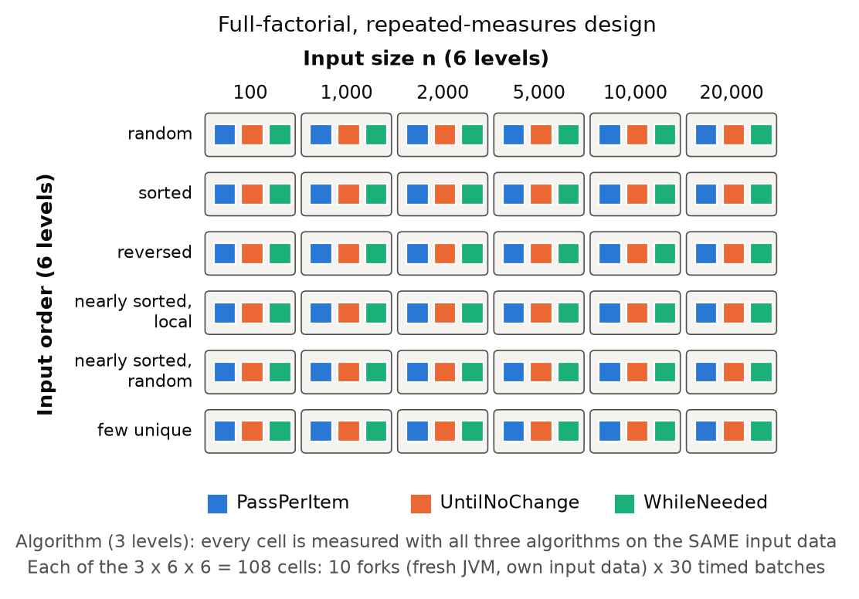
Figure 1. Design of the experiment: three crossed factors (3 × 6 × 6 cells), 10 forks per cell, 30 timed batches per fork; the three algorithms are measured on the same inputs.

2.3 Apparatus and Materials
Hardware and system. Apple MacBook with an Apple M3 Pro (11 cores, 18 GB RAM), macOS 26.7.1, connected to AC power and fully charged during the whole session (battery level is a time threat in laptop benchmarks), lid open, screen on, heavy applications closed. We prevented sleep with caffeinate. The full environment record is stored with the data (results/full/environment.txt).
Software. OpenJDK 26.0.1 (Homebrew build), compiled with the same JDK; Python 3 with pandas, NumPy, SciPy and matplotlib for the analysis. The three sorting classes and the interface Sorter come from the assignment and were not modified (byte-identical copies in src/exp01). Our own code: InputGenerator (deterministic data), Worker (the measuring program), run_experiment.py (orchestrator, one JVM per job), and the analysis scripts. All code and data are public: https://github.com/vaizan4ikys/bubble-sort-benchmark.
How time is measured. Inside the JVM with System.nanoTime(). Sorting an array of 100 elements takes only microseconds, which is too short to time one call reliably. We therefore time a batch of sorts and divide: the batch size is calibrated so that a batch lasts about 2 ms (between 1 and 20 000 sorts per batch). The arrays of a batch are private copies created before the timer starts.

2.4 Procedure
One experimental run (a job) is one JVM process for one (algorithm, order, size, fork) combination:
- The orchestrator starts a fresh JVM (java -Xms2g -Xmx2g -XX:+UseSerialGC exp01.Worker …). The worker generates the input array from (order, n, seed, fork) and creates the one sorter under test.
- Warm-up. The worker sorts fresh copies of the input until at least 20 sorts and 1.5 s have passed and the median of the five most recent sorts is within 5 % of the five before (i.e. the JIT compiler has settled), with a limit of 40 s. For very short sorts (< 100 µs) the time criterion alone ends the warm-up.
- Calibration. From the warm-up speed, the batch size is chosen so that one batch lasts about 2 ms.
- Measurement. 30 times: create the batch of array copies (not timed); start the clock; sort all arrays; stop the clock; check (not timed) that each array is sorted; note whether a garbage collection happened in the timed region. The job is aborted with an error if any result is not sorted.
- The worker prints one CSV line per batch. The orchestrator appends them to raw.csv, runs the 1 080 jobs in randomised order (seed 20261104) and can resume after an interruption.
The whole main experiment took 77 minutes (01:25–02:43 on 4 November 2026). The run was started and supervised by the AI assistant (Claude Code) on Pavlo's laptop, at Pavlo's request; Pavlo had closed his other heavy applications beforehand. While it ran, the assistant made four short git commits (01:30–01:42) and a few low-priority smoke tests, all listed in results/full/interference_log.txt; their effect is checked in Section 3.1. The re-measurement rule was committed at 01:36, during the run and before any main data had been analysed. Because the same ten fork numbers (0–9) are used for all three algorithms, each fork index defines one data set shared by the three algorithms.
Statistics. Per cell, we compute the five-number summary of all 300 batch measurements. For inference we use the 10 fork medians: 95 % confidence intervals from the t distribution (N = 10 is small, so t rather than z), ratios between algorithms as geometric means of the 10 paired per-fork ratios with a t interval on the log scale, and growth factors (t(20 000)/t(10 000)) with a Welch interval. A hypothesis cell is supported when the whole confidence interval satisfies the threshold, falsified when the whole interval lies on the wrong side, and inconclusive otherwise. Re-measurement rule (also pre-registered): a group (order, size ≥ 1 000) is re-measured with 20 additional forks per algorithm if the between-fork variation is above 5 %, the CI half-width is above 3 %, a garbage collection occurred, the warm-up timed out, or any hypothesis cell is inconclusive.
Use of AI. As allowed by the course, an AI assistant (Claude) was used to help design the experiment, write the measuring and analysis code, and draft this report. The authors reviewed the design, the code, the numbers and the text.

3. Results

3.1 Visual Overview
Data quality. All 1 080 jobs completed without errors and every sorted result was verified. The data set contains 32 400 batch measurements (108 cells × 10 forks × 30 batches). No timed batch contained a garbage collection and no warm-up hit its time limit. Time per sort ranges from 25 ns (sorting a sorted array of 100 elements) to 0.52 s (20 000 elements).
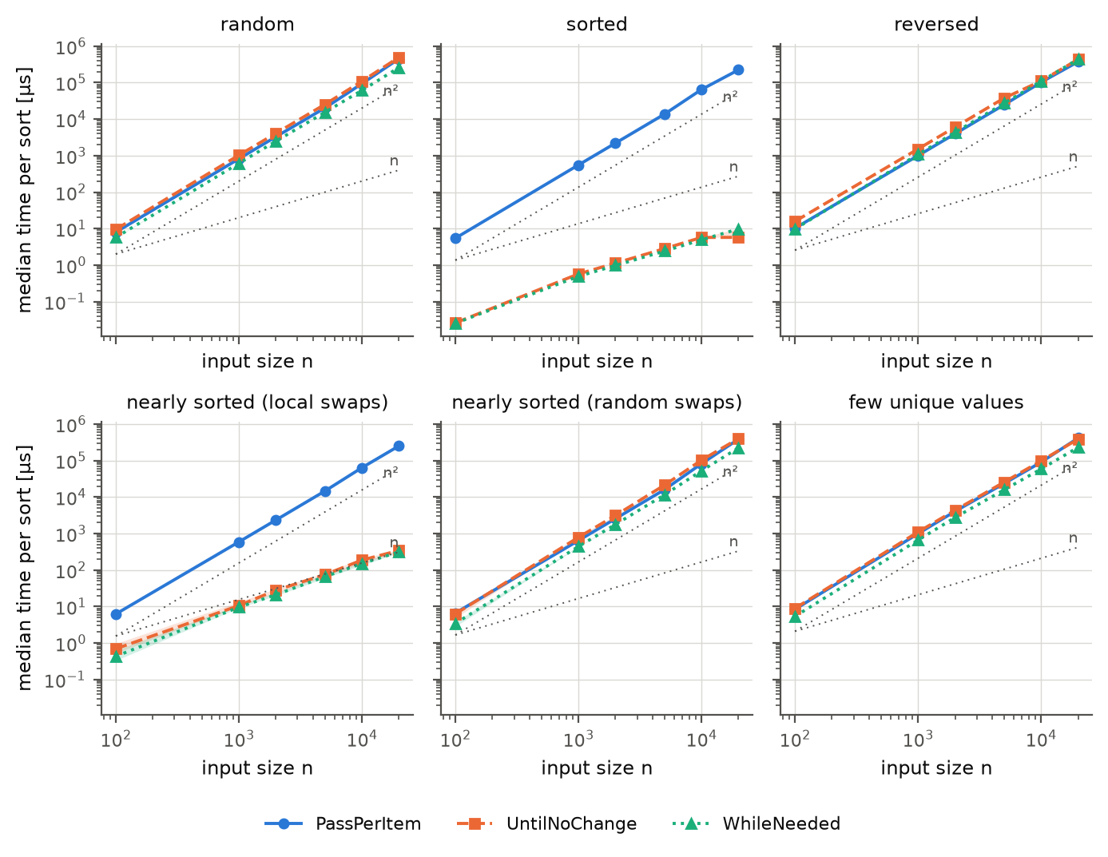
Figure 2. Median running time of one sort (µs, log–log axes) against input size, one panel per input order. Markers are the measured sizes; the shaded band is the 95 % CI over forks (mostly narrower than the markers); dotted grey lines show n and n² growth for reference. Log scales are used because sizes and times span several orders of magnitude.
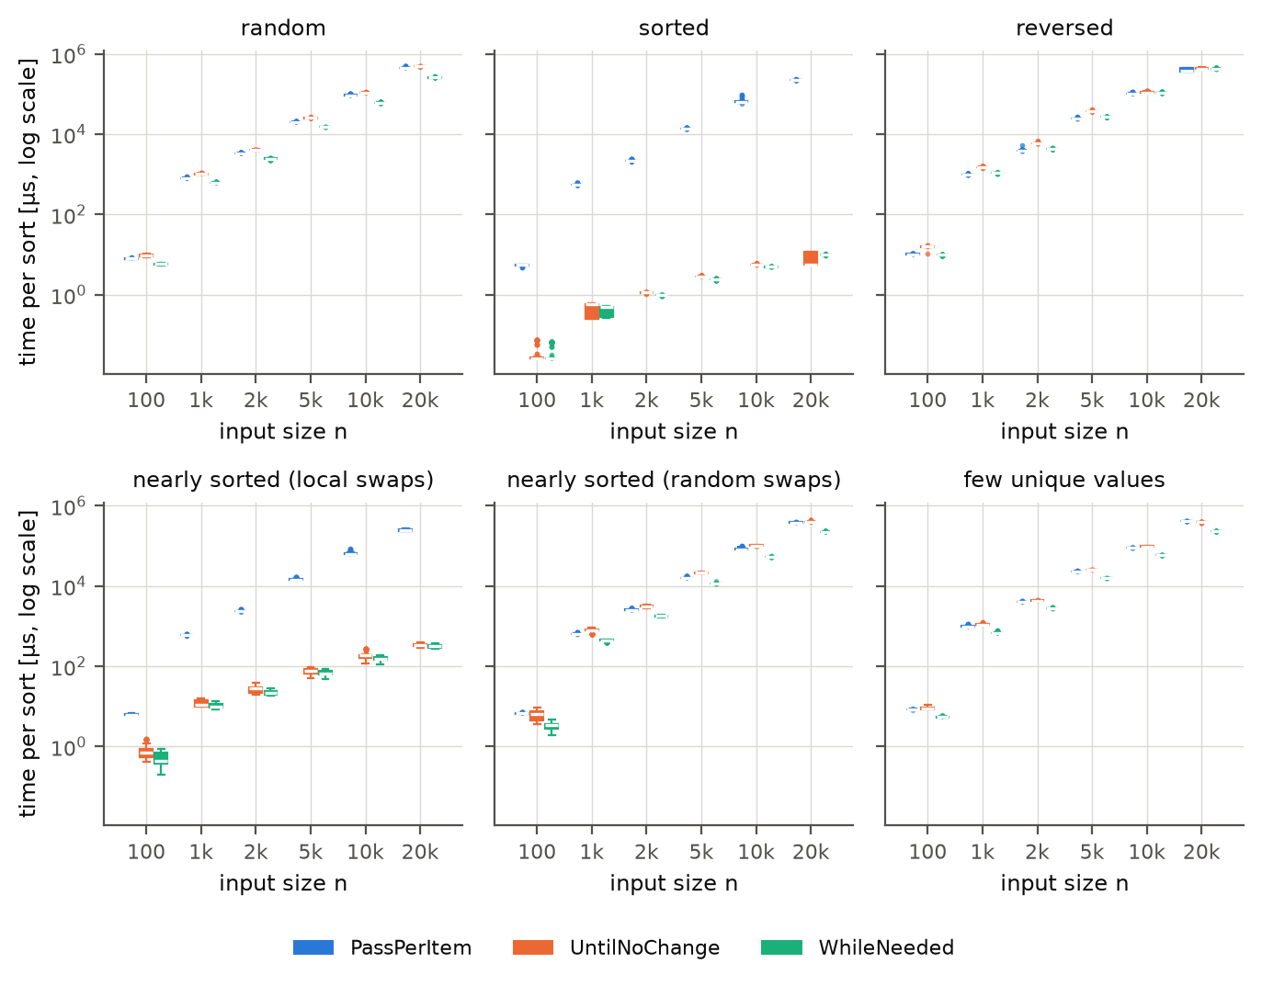
Figure 3. Distribution of the measured time per sort (all 300 batch measurements per box) for n = 5 000 and n = 20 000, by input order and algorithm. Box = interquartile range, line = median, whiskers = 1.5 × IQR, points = outliers.
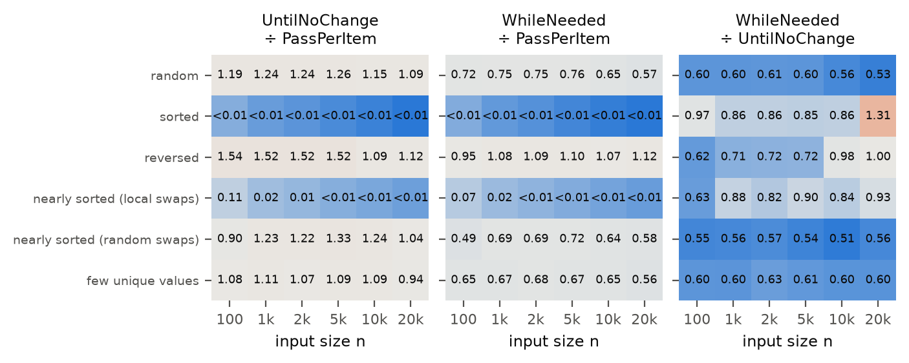
Figure 4. Time of one algorithm relative to another (geometric mean over forks of the paired per-fork ratios). Values below 1 mean the first-named algorithm is faster. Cells with n < 1 000 are descriptive only.
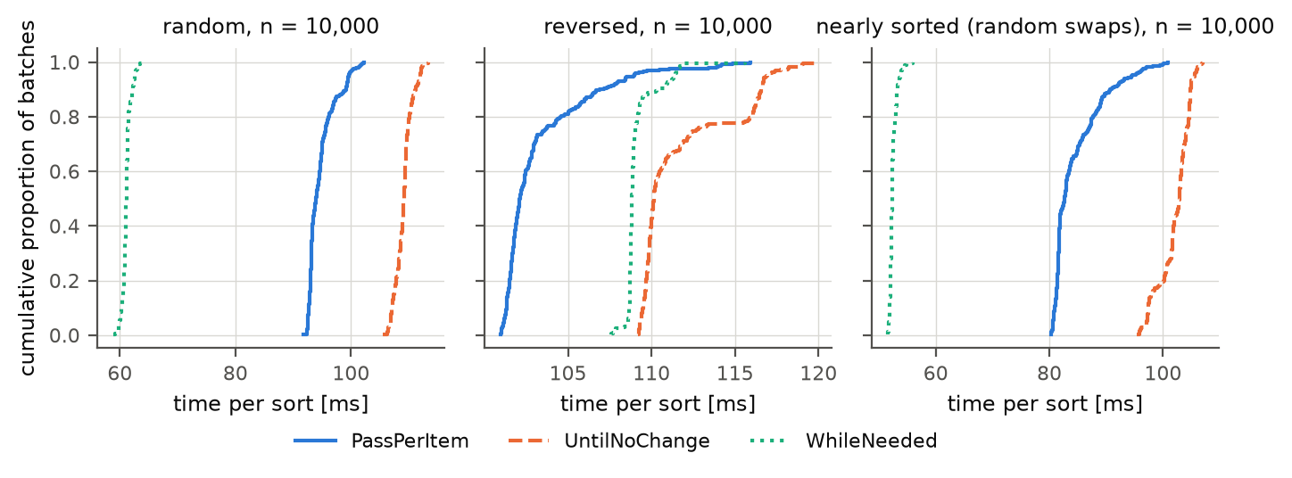
Figure 5. Empirical cumulative distribution functions of the time per sort (random input) for all three algorithms and sizes.
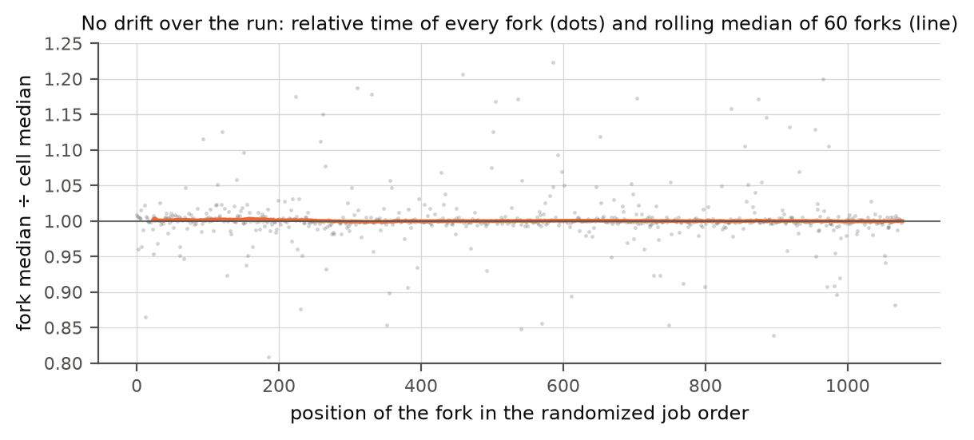
Figure 6. Check for slow drift of the machine during the 77-minute session: relative time of each job (to its cell median) in execution order, with rolling median.
Drift check: Spearman correlation between job position and relative time: ρ=-0.108, p=0.00123. The rolling median of the relative time stays within 0.999 to 1.003 of the cell median (Figure 6), so the drift is statistically detectable but tiny (later jobs were about 0.1–0.3 % faster): far smaller than the differences between algorithms. Our own short checks during the run (smoke tests of later experiments, at lowest priority, logged in results/full/interference_log.txt) did not leave a visible trace.

3.2 Descriptive Statistics
For each of the 108 conditions we summarise the 300 measurements with the five-number summary: the minimum is the fastest batch observed; the first quartile (Q1) is the value below which the fastest quarter of the batches lies; the median is the middle value – half of the batches were faster, half slower; the third quartile (Q3) is the value below which three quarters of the batches lie; the maximum is the slowest batch. The distance Q3 − Q1 (the interquartile range) shows how much the measurements vary: a narrow range means the timing is repeatable. Table 2 gives the summary for n = 10 000; the tables for all sizes are in Appendix C. Times are per call of sort(), in the unit shown.
Table 2. Five-number summary of the time per sort, n = 10 000 (300 measurements per row).
Input order | Algorithm | Min | Q1 | Median | Q3 | Max
random | PassPerItem | 91.7 ms | 93.1 ms | 94.0 ms | 95.6 ms | 102 ms
random | UntilNoChange | 106 ms | 108 ms | 109 ms | 110 ms | 113 ms
random | WhileNeeded | 58.9 ms | 60.8 ms | 61.1 ms | 61.4 ms | 63.9 ms
sorted | PassPerItem | 58.2 ms | 63.4 ms | 64.6 ms | 65.6 ms | 94.8 ms
sorted | UntilNoChange | 5.46 µs | 5.71 µs | 5.72 µs | 5.75 µs | 6.08 µs
sorted | WhileNeeded | 4.87 µs | 4.90 µs | 4.92 µs | 4.96 µs | 5.31 µs
reversed | PassPerItem | 101 ms | 102 ms | 102 ms | 104 ms | 116 ms
reversed | UntilNoChange | 109 ms | 110 ms | 110 ms | 113 ms | 120 ms
reversed | WhileNeeded | 108 ms | 109 ms | 109 ms | 109 ms | 116 ms
nearly sorted (local swaps) | PassPerItem | 60.4 ms | 62.7 ms | 64.1 ms | 65.9 ms | 87.6 ms
nearly sorted (local swaps) | UntilNoChange | 120 µs | 157 µs | 186 µs | 191 µs | 273 µs
nearly sorted (local swaps) | WhileNeeded | 111 µs | 142 µs | 153 µs | 169 µs | 185 µs
nearly sorted (random swaps) | PassPerItem | 80.3 ms | 81.5 ms | 82.7 ms | 86.7 ms | 101 ms
nearly sorted (random swaps) | UntilNoChange | 95.3 ms | 101 ms | 103 ms | 104 ms | 107 ms
nearly sorted (random swaps) | WhileNeeded | 51.5 ms | 52.1 ms | 52.3 ms | 52.7 ms | 55.9 ms
few unique values | PassPerItem | 88.8 ms | 89.6 ms | 89.8 ms | 90.1 ms | 94.7 ms
few unique values | UntilNoChange | 96.8 ms | 97.4 ms | 97.6 ms | 98.1 ms | 99.0 ms
few unique values | WhileNeeded | 58.2 ms | 58.4 ms | 58.5 ms | 58.6 ms | 59.3 ms

The median over forks, the 95 % confidence intervals and the between-fork variation per condition are in the file analysis/out/main/summary_cells.csv.

3.3 Comparing the algorithms
Table 3 gives the paired ratio of the running times for the most informative sizes. Values below 1 mean that the first-named algorithm needs less time.
Table 3. Time ratios (geometric mean over the 10 paired forks) with 95 % confidence interval in brackets.
Input order | n | UntilNoChange ÷ PassPerItem | WhileNeeded ÷ PassPerItem | WhileNeeded ÷ UntilNoChange
random | 1 000 | 1.24 [1.23, 1.26] | 0.75 [0.74, 0.76] | 0.60 [0.60, 0.61]
random | 5 000 | 1.26 [1.24, 1.28] | 0.76 [0.76, 0.76] | 0.60 [0.60, 0.61]
random | 20 000 | 1.09 [1.08, 1.10] | 0.57 [0.57, 0.58] | 0.53 [0.52, 0.53]
sorted | 1 000 | <0.01 [<0.01, <0.01] | <0.01 [<0.01, <0.01] | 0.86 [0.86, 0.87]
sorted | 5 000 | <0.01 [<0.01, <0.01] | <0.01 [<0.01, <0.01] | 0.85 [0.85, 0.86]
sorted | 20 000 | <0.01 [<0.01, <0.01] | <0.01 [<0.01, <0.01] | 1.31 [1.01, 1.68]
reversed | 1 000 | 1.52 [1.51, 1.53] | 1.08 [1.08, 1.08] | 0.71 [0.71, 0.71]
reversed | 5 000 | 1.52 [1.52, 1.53] | 1.10 [1.10, 1.10] | 0.72 [0.72, 0.72]
reversed | 20 000 | 1.12 [1.06, 1.18] | 1.12 [1.05, 1.18] | 1.00 [0.98, 1.02]
nearly sorted (local swaps) | 1 000 | 0.02 [0.02, 0.02] | 0.02 [0.02, 0.02] | 0.88 [0.82, 0.93]
nearly sorted (local swaps) | 5 000 | <0.01 [<0.01, <0.01] | <0.01 [<0.01, <0.01] | 0.90 [0.84, 0.96]
nearly sorted (local swaps) | 20 000 | <0.01 [<0.01, <0.01] | <0.01 [<0.01, <0.01] | 0.93 [0.91, 0.95]
nearly sorted (random swaps) | 1 000 | 1.23 [1.16, 1.30] | 0.69 [0.67, 0.70] | 0.56 [0.54, 0.58]
nearly sorted (random swaps) | 5 000 | 1.33 [1.31, 1.35] | 0.72 [0.72, 0.72] | 0.54 [0.53, 0.55]
nearly sorted (random swaps) | 20 000 | 1.04 [1.03, 1.05] | 0.58 [0.57, 0.58] | 0.56 [0.55, 0.56]
few unique values | 1 000 | 1.11 [1.10, 1.12] | 0.67 [0.66, 0.67] | 0.60 [0.60, 0.60]
few unique values | 5 000 | 1.09 [1.08, 1.10] | 0.67 [0.67, 0.67] | 0.61 [0.61, 0.62]
few unique values | 20 000 | 0.94 [0.93, 0.94] | 0.56 [0.56, 0.56] | 0.60 [0.59, 0.60]

3.4 Operation counts and cost model
To relate time to the work performed, an instrumented copy of the algorithms counted the comparisons (calls to compareTo) and the number of inversions (= swaps, identical for all three algorithms) for every cell (results/operation_counts.csv). A least-squares model time ≈ a · comparisons + b · swaps per algorithm, fitted over the 30 cells with n ≥ 1 000, gives:
Table 4. Cost model fitted on the cells with n ≥ 1 000.
Algorithm | a (ns per comparison) | b (ns per swap) | R² (weighted)
PassPerItem | 0.62 | 0.91 | 0.978
UntilNoChange | 0.58 | 1.77 | 0.907
WhileNeeded | 0.61 | 1.48 | 0.958

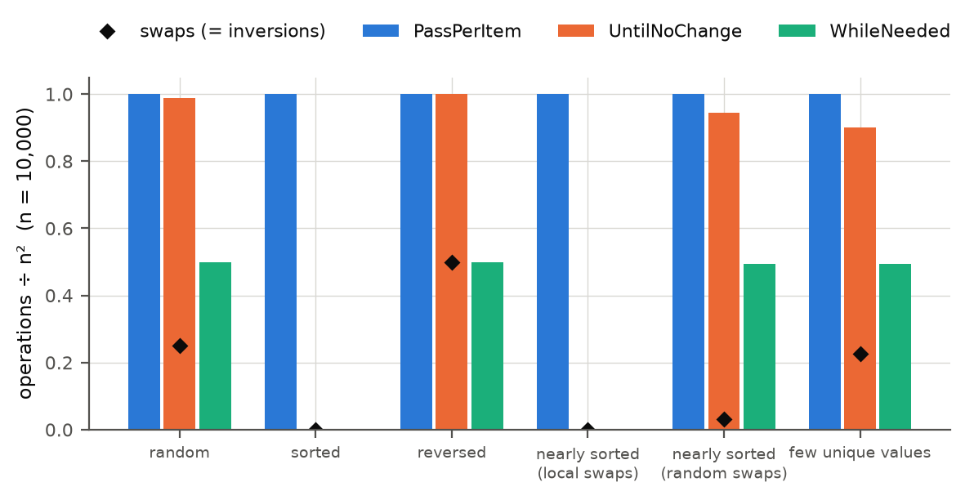
Figure 7. Comparisons per algorithm and input order (n = 10 000), and measured time against comparisons.

3.5 Decision metric: worst-case slowdown
For the recommendation, we compare every algorithm with the fastest one in each condition. The slowdown of an algorithm in a cell is its median time divided by the smallest median time of the three algorithms in that cell (1.00 = fastest). Table 5 summarises the 30 cells with n ≥ 1 000.
Table 5. Slowdown relative to the fastest algorithm per cell (n ≥ 1 000).
Algorithm | Fastest in | Within 5 % of best | Geometric-mean slowdown | Worst slowdown | Where
PassPerItem | 5 / 30 | 5 / 30 | 12.80 | 38 857.43 | sorted n=20000
UntilNoChange | 1 / 30 | 1 / 30 | 1.45 | 1.96 | nearly_random n=10000
WhileNeeded | 24 / 30 | 24 / 30 | 1.03 | 1.70 | sorted n=20000

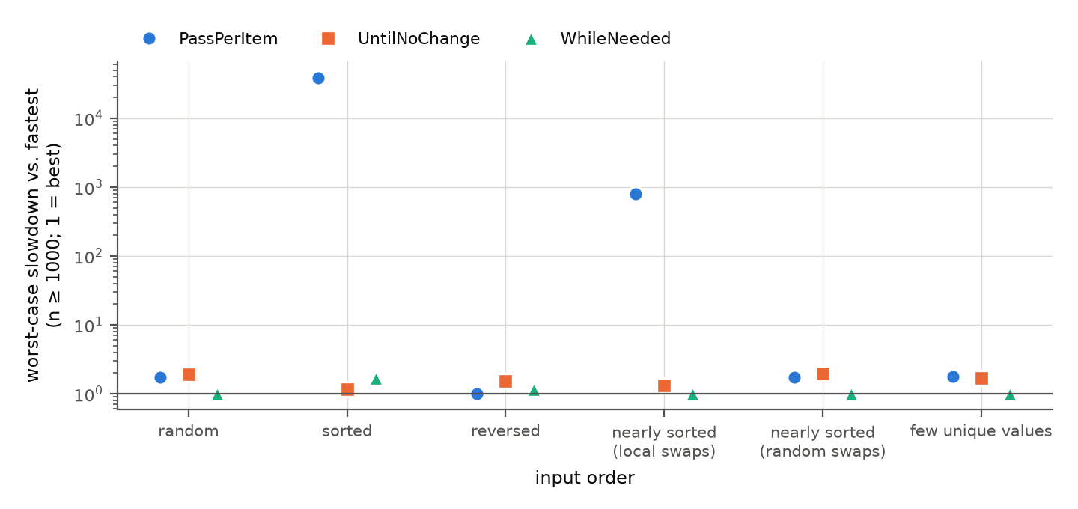
Figure 8. Worst slowdown relative to the best algorithm per input order (n ≥ 1 000; logarithmic axis, 1 = best).

3.6 Hypothesis checks
Table 6. Verdicts of the pre-registered hypotheses based on the main data (before re-measurement).
Hypothesis | Overall verdict | Cells supported | Cells falsified | Cells inconclusive
H1 | Supported | 10 | 0 | 0
H2 | Partly falsified | 7 | 1 | 1
H3 | Partly falsified | 1 | 5 | 0
H4 | Supported | 6 | 0 | 0
H5 | Partly falsified | 5 | 1 | 0
H6 | Partly falsified | 54 | 5 | 1

3.7 Robustness experiments
The main experiment answers the question for one machine, one JDK, one garbage collector, one element type and a clean JVM. To find out whether the recommendation depends on these choices, we ran the follow-up experiments of Table 7. Their first two queues were scripted before the main data existed (scripts/run_followups.sh, run_followups2.sh); the runs on other computers and the real JDK 25 run (Section 3.7.9) were added after seeing the results. They use the same measuring procedure and the same fork-and-batch structure but fewer forks (5 per cell, unless stated), and they were run after the main experiment on the same machine (except Section 3.7.9). They are descriptive checks of the consistency of the ranking; we did not pre-register thresholds for them.
Table 7. Follow-up experiments.
Experiment | Question | Design
String elements | Does the ranking change if comparisons are expensive? | String instead of Integer, 6 orders × 5 sizes × 3 algorithms × 5 forks
Garbage collector | Is the result specific to SerialGC (JVM default is G1, whose array stores carry write barriers)? | G1 and ParallelGC, 6 orders × 3 sizes × 5 forks
JDK version | Is it specific to JDK 26 (different JIT compilers)? | JDK 8, 17, 21, 25.0.5, and a repeat on JDK 26.0.1 (a first JDK 25 run in fact used JDK 26, see Section 3.7.2); 6 orders × 3 sizes × 5 forks
Polluted JIT profile | Real programs sort many element types; does the ranking survive megamorphic compareTo calls? | 900 ms of sorting Strings, Longs and custom objects before measuring Integers; 5 orders × 3 sizes × 5 forks
Tiny arrays | What is best for n = 2 … 50? | 8 input orders × 6 sizes × 5 forks
Other input shapes | Classic bubble-sort cases | turtle, rabbit, sorted + random tail, organ pipe, sawtooth; 3 sizes × 5 forks
JIT compiler level | Are the anomalies caused by the optimising compiler (C2)? | only C1 (-XX:TieredStopAtLevel=1) and interpreter only (-Xint); 6 orders × 100–2 000 (interpreter) / 10 000 (C1) × 5 forks
Cold start | What if the program sorts only a few times (no JIT warm-up)? | first 50 calls of a fresh JVM, 30 JVMs per cell
JMH | Is our own harness biased? | JMH 3 forks × 10 iterations, 3 orders × 2 sizes
Scaling | Exact growth exponent? | random, sorted; 12 sizes from 200 to 40 000
Other computers | Does the result depend on this laptop or on ARM? | x86 desktop and a second M3 Pro laptop; 6 orders × 3 sizes × 5 forks
Replication, load, correctness | Reproducible with other data? Sensitive to busy machine? Are the sorters correct? | full design with a new seed; 6 busy processes; 20 139 functional checks

3.7.1 Element type: String instead of Integer
When the elements are Strings, comparing two elements costs much more than swapping two references, so the number of comparisons matters more. The ranking then follows the comparison counts: on reversed input (n = 5 000) WhileNeeded needs 0.58× the time of PassPerItem (CI 0.58–0.59) instead of 1.10× with Integers, and the gap between UntilNoChange and PassPerItem on random input disappears (0.98× instead of 1.25×). WhileNeeded is the fastest algorithm in every String condition with n ≥ 1 000, except that it ties with UntilNoChange on sorted input.
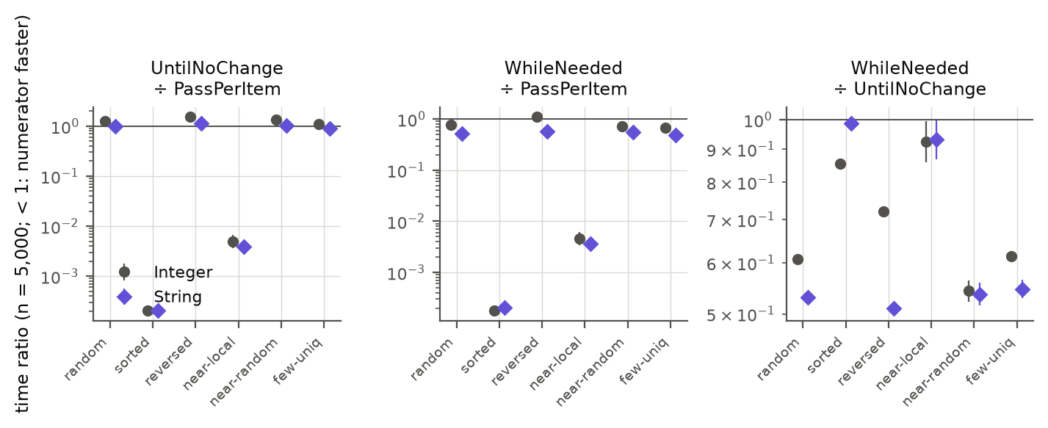
Figure 9. Time ratios at n = 5 000 for Integer and String elements (log axis; below 1 means the numerator is faster; bars are 95 % CIs).

3.7.2 Garbage collector, JDK version and JIT profile
Figure 10 compares the three pairwise ratios at n = 5 000 across all settings, and Table 8 the slowdown relative to the best algorithm in each cell. Two observations stand out. First, the ranking for random, sorted, nearly sorted and few-unique inputs is the same in every setting: WhileNeeded fastest, UntilNoChange slowest on random-like data, PassPerItem catastrophically slow on sorted and locally disturbed data. Second, the single anomaly of the main experiment – WhileNeeded about 10 % slower than PassPerItem on reversed input – occurs in the main setting (JDK 26.0.1 on this Mac), in its repeat run and with the Parallel collector. With G1 (the JVM default), on JDK 8, 17, 21 and 25.0.5, and on the two other machines of Section 3.7.9, WhileNeeded is as fast as or faster than PassPerItem on reversed input. (The row "JDK 26 (repeat run)" was planned as JDK 25, but the Homebrew package openjdk@25 on this Mac turned out to contain JDK 26.0.1, as the environment file of that run shows; it is therefore a repeat of the main setting, and it reproduces the main result. A real JDK 25 was measured afterwards, row "JDK 25 (this Mac)", see Section 3.7.9.)
Table 8. Per setting (n ∈ {1 000, 5 000, 10 000}; polluted: {1 000, 5 000}): in how many (order, size) cells each algorithm is fastest, and the worst slowdown relative to the best algorithm in a cell.
Setting | PassPerItem fastest | UntilNoChange fastest | WhileNeeded fastest | WhileNeeded worst slowdown | UntilNoChange worst slowdown | PassPerItem worst slowdown
main: JDK 26, SerialGC | 3/18 | 0/18 | 15/18 | 1.10 | 1.96 | 13 124
JDK 26, G1 GC | 0/18 | 0/18 | 18/18 | 1.00 | 1.91 | 10 650
JDK 26, ParallelGC | 3/18 | 0/18 | 15/18 | 1.10 | 1.85 | 8 392
JDK 26 (repeat run) | 3/18 | 0/18 | 15/18 | 1.10 | 1.94 | 12 985
JDK 25 (this Mac) | 0/18 | 1/18 | 17/18 | 1.00 | 2.21 | 10 869
JDK 21 | 0/18 | 0/18 | 18/18 | 1.00 | 1.84 | 9 915
JDK 17 | 0/18 | 0/18 | 18/18 | 1.00 | 1.90 | 9 938
JDK 8 | 0/18 | 0/18 | 18/18 | 1.00 | 1.91 | 12 996
JDK 26, polluted JIT profile | 0/10 | 2/10 | 8/10 | 1.10 | 1.82 | 5 176
2nd M3 Pro, JDK 25.0.1 | 0/18 | 1/18 | 17/18 | 1.01 | 2.50 | 10 832
Ryzen 5 5600 (x86), JDK 26 | 0/18 | 0/18 | 18/18 | 1.00 | 2.44 | 11 568

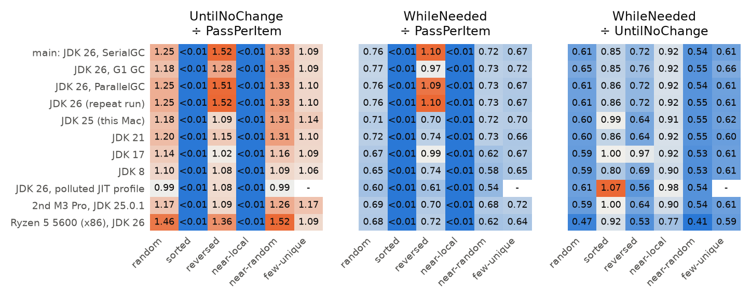
Figure 10. Time ratios at n = 5 000 for different garbage collectors, JDK versions and a polluted JIT profile (same data in every setting).
The absolute speed does depend on the setting, but only little for GC and JDK version (geometric mean within about ±10 % of the main setting, the extremes being cells with a few percent of timing noise). The polluted JIT profile is different: when the JIT compiler has already seen other element types, every algorithm becomes slower by a factor of 2.8–3.7 (geometric mean over cells), because the call to compareTo can no longer be inlined. The ranking nevertheless survives: WhileNeeded is fastest in 8 of 10 polluted cells and never more than 10 % behind the best; it needs about 40 % less time than PassPerItem on random and reversed input – so with a polluted profile the reversed-input disadvantage of the main experiment is gone. The absolute times in Section 3 are therefore a best case for a clean JVM, not a prediction for a real application.
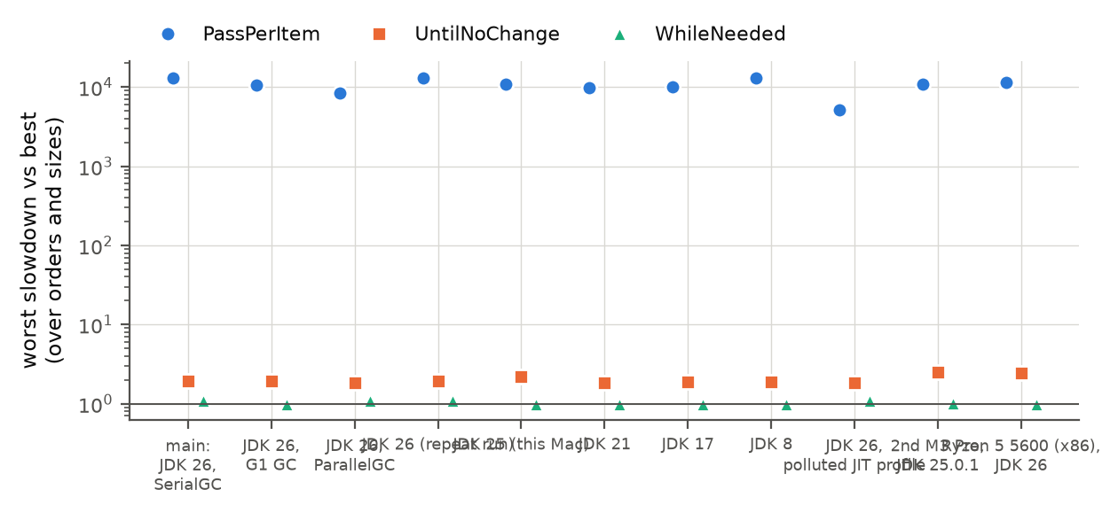
Figure 11. Worst slowdown relative to the best algorithm in a cell, per setting (log axis).

3.7.3 Tiny arrays (n = 2 … 50)
For arrays of 50 or fewer elements one sort takes between tens of nanoseconds and a few microseconds, and the differences between the algorithms are small (a few nanoseconds) and noisy. WhileNeeded is the fastest algorithm in 77 % of the 48 (order, size) combinations; UntilNoChange and PassPerItem win the rest. The fastest algorithm is on median 1.25× faster than the second fastest (range 1.01–1.92×), and the confidence intervals in Figure 12 overlap. At this scale the choice of algorithm has no practical consequence compared with, e.g., the cost of calling the method, and no algorithm is reliably best.
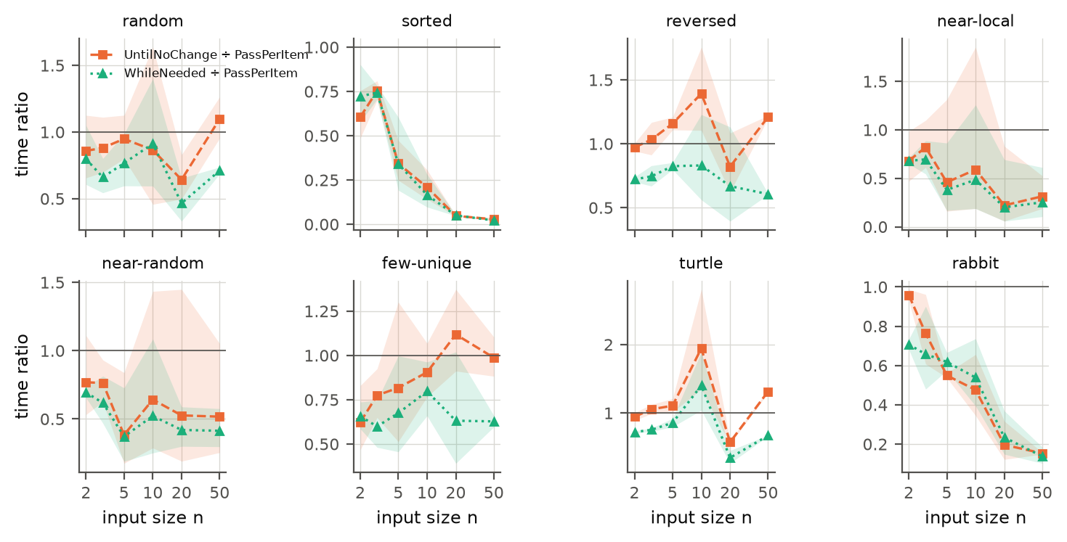
Figure 12. Time of UntilNoChange and WhileNeeded relative to PassPerItem for very small arrays (bands: 95 % CI).

3.7.4 Other classic input shapes
The five additional shapes are turtle (a small element at the very end, which bubble sort moves left only one position per pass), rabbit (a large element at the start, which moves to the end in one pass), a sorted array with a random 10 % tail, an organ pipe and a sawtooth. For n = 5 000: WhileNeeded needs 0.67× the time of PassPerItem on the turtle, 0.52× on sorted + tail, 0.52× on the organ pipe and 0.55× on the sawtooth, and is about as fast as UntilNoChange on the rabbit (both ≈ 1000× faster than PassPerItem). UntilNoChange is up to 1.32× slower than PassPerItem on the turtle. WhileNeeded is the fastest algorithm in 13 of 15 shape/size cells and never more than 0.8 % slower than the best.
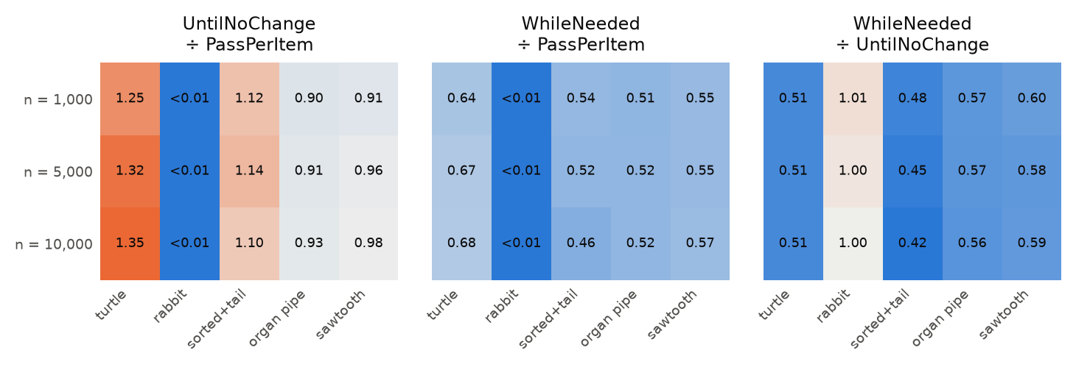
Figure 13. Time ratios for the additional input shapes.

3.7.5 Cold start
A program that sorts only a handful of times never reaches the optimised code that the main experiment measures. We timed the first 50 calls in 30 fresh JVMs per condition. Figure 14 shows that the very first call of PassPerItem on random input takes 46× the steady-state time for n = 100, 12× for n = 1 000 and 1.2× for n = 10 000 (the code is interpreted, then compiled in stages; a long-running loop is compiled while it runs), and that the steady state is reached after 10–20 calls for n = 100 and 1 000. In the cold phase the ranking is similar: for random input WhileNeeded is fastest in all 12 of 12 checkpoints (first call, first 5 calls, first 20 calls). On reversed input, PassPerItem becomes slightly faster for n ≥ 1 000 after about 5 calls, as in the main experiment; on sorted input the early-stopping algorithms need only 0.2–36 % of PassPerItem's time, depending on n and the number of calls.
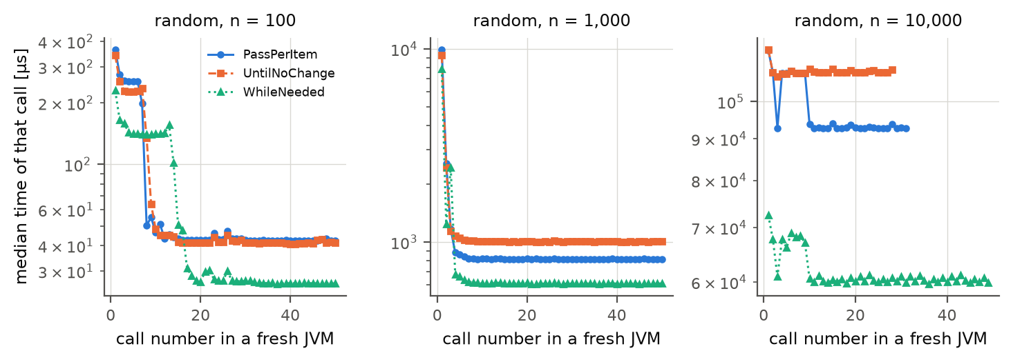
Figure 14. Median time of the k-th call in a fresh JVM (random input), n = 100, 1 000 and 10 000 (log axis; 30 JVMs per curve).

3.7.6 Cross-check with JMH
JMH is the standard Java micro-benchmark harness. We ran it on a subset (random, reversed and nearly-local input; n = 5 000 and 20 000; 3 JVMs, 10 iterations of 1 s, one sort per invocation) and compared the ratios between the algorithms with ours. For random and reversed input the ratios agree to within 1.2 % (ratio of ratios 0.990–1.012), so our hand-written harness does not bias the comparison. On nearly-local input the ratios are very small (≈0.003) and differ by up to a factor 1.8 because JMH sorts a single fixed random input whereas we draw a new one per fork; the conclusion (hundreds of times faster than PassPerItem) is the same.

3.7.7 Scaling, replication, load and correctness
Scaling. Fitting time = c · n^k on 12 sizes between 1 000 and 40 000 gives exponents k (95 % CI) on random input of 2.12 (2.11–2.14) for PassPerItem, 2.08 (2.06–2.09) for UntilNoChange and 2.02 (2.01–2.03) for WhileNeeded; on sorted input 2.01 (1.98–2.04) for PassPerItem and 1.01 (1.00–1.01) and 1.01 (1.00–1.01) for the two others. The growth is quadratic (PassPerItem a bit steeper than 2, consistent with the H5 result) and linear, respectively.
Replication. The complete main design was repeated with a different random seed (new data, new JVMs). Of the 108 cell medians, 94 % differ from the main data by less than 5 % and 98 % by less than 10 %. For n ≥ 1 000 the median absolute difference is 0.1 % and the largest 18.9 %. The Spearman correlation of the cell medians is 0.9999. The only larger deviations are the two nearly-sorted cells with local swaps at n = 5 000 (−16 % and −19 %), which have the highest between-data variation (see Section 3.8).
Load. Under load the median slowdown is 1.057× (range 1.048–1.364). From idle to load, the median CV between forks rises from 1.3 % to 1.7 %, and the median relative IQR of the batches from 1.6 % to 25.7 %. Six busy background processes thus slow the sorts by about 6 % on average but make single batches far more variable, which confirms that benchmarks must be run on an otherwise idle machine – as ours was, apart from the logged short tests (Section 2.4).
Correctness. The three sorters passed all 20 139 checks: every permutation of up to 7 elements, 600 random arrays against Arrays.sort, all 11 input shapes, stability, and in-place behaviour (results/correctness/correctness.txt). All timed results in every experiment were also verified to be sorted. The timing comparison therefore compares correct, equivalent sorters.

3.7.8 JIT compiler level
HotSpot first interprets the bytecode, then compiles hot loops with the fast C1 compiler and finally with the optimising C2 compiler. We repeated the experiment with C2 switched off (C1 only) and with the compiler switched off entirely (interpreter only), at n = 2 000 (the interpreter is too slow for larger sizes). With the default JIT, UntilNoChange needs 1.22× the time of PassPerItem on random input and WhileNeeded 1.09× on reversed input. With only C1 these ratios are 1.05 and 0.64, and in the interpreter 0.98 and 0.56. Without C2 the running time simply follows the number of comparisons: WhileNeeded needs 0.53–0.66× the time of PassPerItem on random and reversed input, UntilNoChange equals PassPerItem. The two main surprises of the main experiment (UntilNoChange slower than PassPerItem on random input; WhileNeeded slower than PassPerItem on reversed input) are therefore properties of the code that the C2 compiler generates, not of the algorithms.
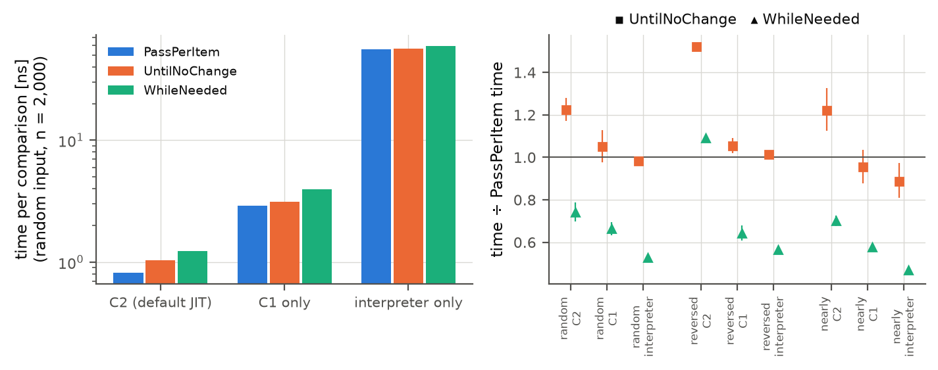
Figure 15. Effect of the JIT compiler level at n = 2 000: time per comparison on random input (left) and time ratios to PassPerItem (right) with the default JIT, with C1 only and in the interpreter.

3.7.9 Other computers
All measurements so far come from one laptop. To test whether the conclusions depend on it, we repeated the reduced design (6 input orders × n = 1 000, 5 000, 10 000 × 3 algorithms × 5 forks × 20 batches; same code, seed and JVM flags) on an x86 desktop (AMD Ryzen 5 5600, 6 cores, 16 GB RAM, Windows 11) and on a second Apple M3 Pro laptop (macOS 27). Table 9 lists the runs next to the matching data from the main laptop. The JDK of each run is taken from its environment record. The main-laptop JDK 17 row comes from the JDK follow-up, which uses ExtendedWorker with the same procedure. Machine and JDK are not fully crossed, and the JDK builds differ slightly, so this is a descriptive check.
Table 9. The same design on different computers and JDKs (n ∈ {1 000, 5 000, 10 000}, 18 cells). Slowdown is relative to the fastest algorithm per cell. Spread: median of (max − min) / median of the batches of one fork.
Run | JDK | Forks | WhileNeeded fastest | Worst slowdown: WhileNeeded | Worst slowdown: UntilNoChange | Worst slowdown: PassPerItem | PassPerItem ÷ WhileNeeded, reversed, n = 5 000 | Spread within a fork
M3 Pro laptop 1, JDK 26 (main) | 26.0.1 | 10 | 15/18 | 1.10 | 1.96 | 13 130 | 0.91 [0.91, 0.91] | 4.9 %
M3 Pro laptop 1, JDK 17 | 17.0.19 | 5 | 18/18 | 1.00 | 1.90 | 9 938 | 1.01 [0.98, 1.04] | 2.7 %
M3 Pro laptop 1, JDK 25 | 25.0.5 | 5 | 17/18 | 1.00 | 2.21 | 10 869 | 1.43 [1.42, 1.44] | 5.1 %
M3 Pro laptop 2, JDK 25 | 25.0.1 | 5 | 17/18 | 1.01 | 2.50 | 10 832 | 1.44 [1.39, 1.48] | 6.2 %
Ryzen 5 5600, JDK 26 | 26.0.2.1 | 5 | 18/18 | 1.00 | 2.44 | 11 568 | 1.38 [1.37, 1.39] | 10.2 %
Ryzen 5 5600, JDK 17 | 17.0.21 | 5 | 17/18 | 1.06 | 2.22 | 11 517 | 1.56 [1.47, 1.67] | 28.2 %

The recommendation holds. On the x86 desktop with JDK 26, WhileNeeded is the fastest algorithm in 18/18 cells, while UntilNoChange is up to 2.44× and PassPerItem up to 11 568× slower than the best. Absolute times differ, but the largest effect (early stopping on sorted input) has the same order of magnitude in every run.
The reversed-input anomaly does not transfer. With the same major JDK version, PassPerItem needs 1.38× the time of WhileNeeded on the desktop (n = 5 000, CI 1.37–1.39), against 0.91× (CI 0.91–0.91) on the main laptop: the direction is reversed. So the anomaly does not follow from JDK 26 alone. With one computer per architecture and no inspection of the machine code, we cannot attribute it to the CPU architecture itself (Figure 16).
Data quality. The desktop is noisier than the main laptop: the spread within a fork is 10.2 % against 4.9 %. Reversed input has two outlier JVMs: at n = 1 000 one fork has a ratio of 1.01, and at n = 10 000 one has 3.38, so the geometric means at these sizes have wide intervals while the median fork ratios stay near 1.38–1.39. The JDK 17 desktop run is weaker still (28.2 % spread, power state not recorded); its decimal commas (old code on a non-English locale) were repaired during analysis, leaving the raw file as measured. The measurements of these runs are in Appendix D.
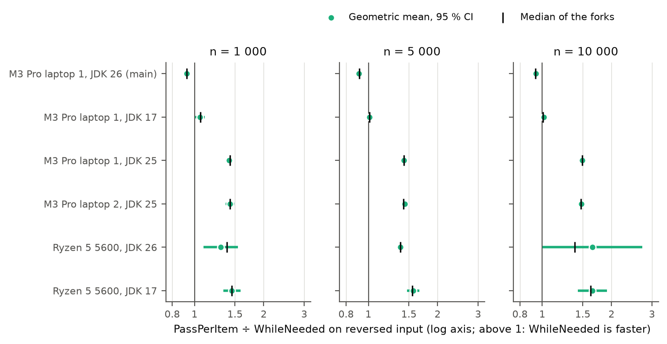
Figure 16. PassPerItem ÷ WhileNeeded on reversed input per computer and JDK: geometric mean of the paired forks with 95 % CI, and the median of the per-fork ratios.
JDK 25 on the main laptop. To separate the Java version from the hardware we also measured a real JDK 25 on the main laptop, with the same macOS and JVM flags but with Temurin instead of Homebrew, ExtendedWorker and 5 forks × 20 batches (the ExtendedWorker repeat on JDK 26.0.1 reproduces the main result): WhileNeeded ÷ PassPerItem on reversed input at n = 5 000 is 0.70 (CI 0.70–0.70) with Temurin 25.0.5, i.e. WhileNeeded is clearly faster and the anomaly is absent. On the same laptop the anomaly therefore disappears when the JDK changes from the Homebrew OpenJDK 26.0.1 of the main experiment to Temurin 25.0.5, so the laptop alone does not cause it; the desktop result (Temurin 26.0.2.1) shows that the major version 26 alone does not cause it either. Our data cannot tell whether it is a property of JDK 26.0.1, of this Homebrew build, or of JDK 26 combined with the M3 Pro: we have no run of JDK 26.0.1 on x86 or of JDK 26.0.2.1 on the M3 Pro. This JDK 25 run was made with the laptop on battery power (39 % at the start, 33 % at the end), unlike the main run; its spread within a fork (5.1 %) is similar to the main run (4.9 %). The Homebrew package openjdk@25 had also been used for the first attempt, which silently ran JDK 26.0.1 (Section 3.7.2).

3.8 Re-measurement of uncertain conditions
The pre-registered rule (Section 2.4) flagged 10 of the 30 (order, size ≥ 1 000) groups as uncertain. These were measured again with 20 additional forks per algorithm (fork ids 10–29), so that they now have 30 forks (900 batches per cell), and we report the pooled data next to the main data. Table 10 lists the groups and why they were flagged.
Table 10. Groups re-measured with 20 additional forks.
Input order | n | Reason(s) for re-measuring (rule in REMEASURE_RULE.md)
nearly sorted (local swaps) | 1 000 | UntilNoChange: CV 20.1 %; UntilNoChange: CI half-width 14.3 %; WhileNeeded: CV 13.5 %; WhileNeeded: CI half-width 9.6 %
nearly sorted (local swaps) | 2 000 | UntilNoChange: CV 19.7 %; UntilNoChange: CI half-width 14.1 %; WhileNeeded: CV 12.9 %; WhileNeeded: CI half-width 9.2 %
nearly sorted (local swaps) | 5 000 | UntilNoChange: CV 16.6 %; UntilNoChange: CI half-width 11.9 %; WhileNeeded: CV 16.2 %; WhileNeeded: CI half-width 11.6 %
nearly sorted (local swaps) | 10 000 | UntilNoChange: CV 22.6 %; UntilNoChange: CI half-width 16.2 %; WhileNeeded: CV 13.2 %; WhileNeeded: CI half-width 9.4 %
nearly sorted (local swaps) | 20 000 | UntilNoChange: CV 9.4 %; UntilNoChange: CI half-width 6.7 %; WhileNeeded: CV 9.7 %; WhileNeeded: CI half-width 6.9 %
nearly sorted (random swaps) | 1 000 | UntilNoChange: CV 8.1 %; UntilNoChange: CI half-width 5.8 %
nearly sorted (random swaps) | 2 000 | UntilNoChange: CI half-width 3.3 %
random | 10 000 | H2 inconclusive (UntilNoChange / PassPerItem within 0.85-1.15)
reversed | 20 000 | PassPerItem: CV 7.9 %; PassPerItem: CI half-width 5.7 %
sorted | 20 000 | UntilNoChange: CV 36.9 %; UntilNoChange: CI half-width 26.4 %; H6 inconclusive (WhileNeeded / UntilNoChange <= 1.05)

Effect on the hypothesis verdicts. After pooling, one hypothesis cell changes: H2, UntilNoChange / PassPerItem within 0.85-1.15, random n = 10000: inconclusive → falsified (1.161, CI 1.153–1.168). All other cells keep their verdict, so the main conclusions do not depend on the re-measurement. The overall verdicts remain: H1 and H4 supported; H2, H3, H5 and H6 partly falsified. The cost-model coefficients are stable (R² ≥ 0.96).
Why were the groups uncertain? There are two different reasons. (1) Nearly sorted with local swaps (all five sizes): here the between-fork variation (CV 10–23 %) is not measurement noise. Each fork uses a different random input (5 % of the elements displaced), and the running time of the early-stopping algorithms depends strongly on how far the most displaced element has to travel, i.e. on the data. The 30 forks give a better estimate of the distribution of running times over such inputs, but the spread remains. The pairwise ratios are paired by data set and stay tight. (2) Sorted input, n = 20 000, UntilNoChange: the JIT compiler ends in one of two states. In the pooled data 40 % of the JVMs ran the sort in about 5.7 µs and 60 % in about 11.4 µs, with no values in between, while WhileNeeded was stable at 9.8 µs. A single JVM therefore can give either ordering of the two early-stopping algorithms on this input, and we cannot state which of them is faster there; the hypothesis cell stays inconclusive. This is a property of the JVM, not a flaw of the measurement, and a practical reminder that single JVM runs can mislead.
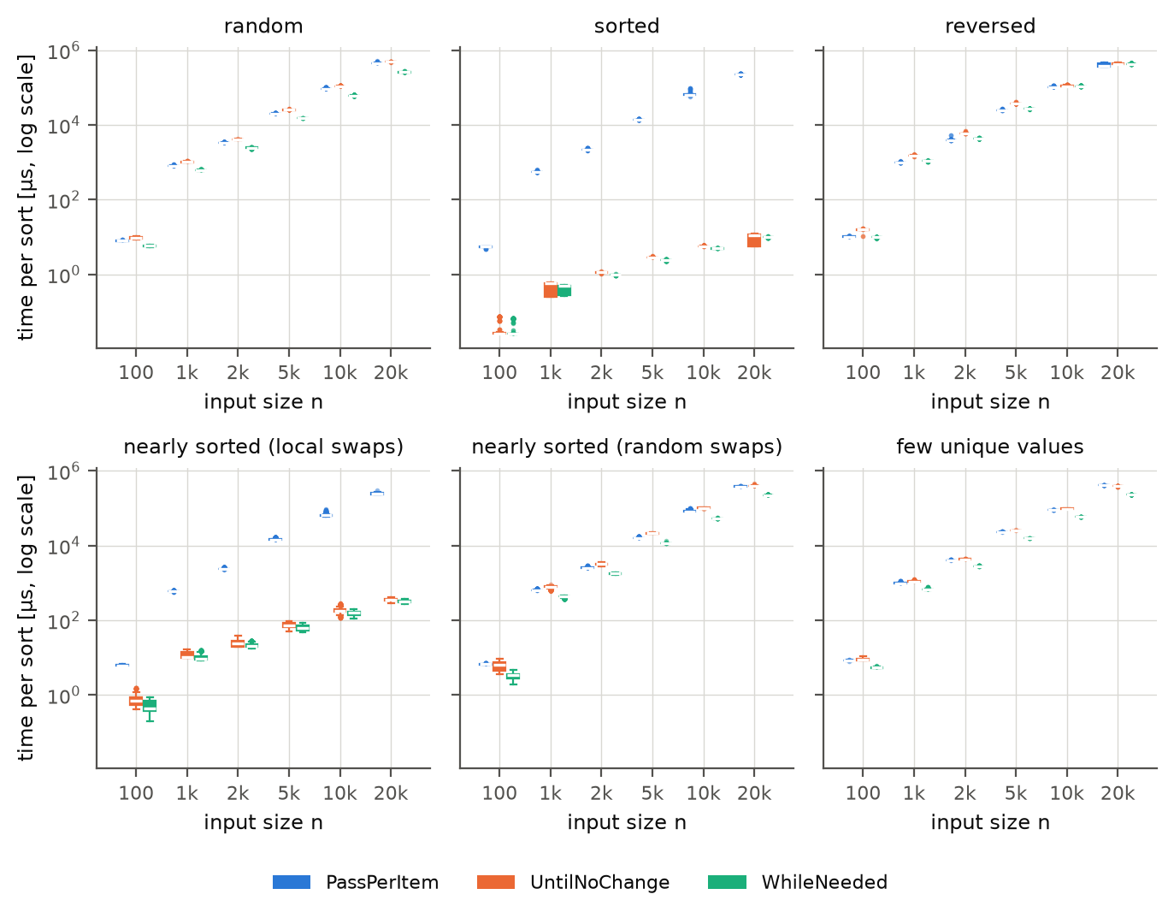
Figure 17. Pooled data (main + re-measurement): distribution of the time per sort at n = 5 000 and 20 000 (compare Figure 3).

4. Discussion

4.1 Compare Hypothesis to Results
H1 – sorted input: supported. PassPerItem is between 970× and 29 807× slower than the early-stopping algorithms (lowest CI bound 965×), far beyond the predicted 100×. The reason is mechanical: PassPerItem makes n(n−1) comparisons whatever the input, while the others make a single pass of n−1 comparisons.
H2 – random input: partly falsified. The first part holds: WhileNeeded is the fastest algorithm in every random cell with n ≥ 5 000 (it needs 0.57–0.76 of PassPerItem's time). The second part (UntilNoChange and PassPerItem within 15 % of each other) is falsified at n = 5 000 (UntilNoChange is 1.26× PassPerItem, CI 1.24–1.28), inconclusive at 10 000 (1.15×) and supported at 20 000 (1.09×). We expected identical work for the two algorithms (about n² comparisons on random data), so the gap must come from the cost per comparison: UntilNoChange additionally updates a flag inside the swap branch, and the JIT-compiled inner loop and the branch predictor evidently handle that code less well. The JIT-level follow-up (Section 3.7.8) supports this: with only the C1 compiler or the interpreter the gap disappears (UntilNoChange ≈ PassPerItem), so it is created by the optimising C2 compiler. We did not inspect the generated machine code, so the exact mechanism remains a hypothesis.
H3 – reversed input: partly falsified. WhileNeeded is clearly faster than UntilNoChange at n = 5 000 (0.72×), but it is not 10 % faster than PassPerItem anywhere – it is in fact 10 % slower at n = 5 000 (CI 1.10–1.10) – and at n ≥ 10 000 it is no faster than UntilNoChange either (1.00× at 20 000). On reversed input every pair of neighbours is out of order, so all three algorithms perform the same n(n−1)/2 swaps, and the number of comparisons is what differs: PassPerItem compares every pair n times, WhileNeeded about half as often. With cheap Integer comparisons the run time is dominated by the memory stores and the branch behaviour of the swaps, and the simple loop of PassPerItem is apparently compiled into slightly faster code than WhileNeeded's loop, which also tracks the last swap position. The follow-up experiments support this reading: the 7–12 % disadvantage occurs only in the main setting (Homebrew OpenJDK 26.0.1 on the first M3 Pro, Serial or Parallel collector). With the G1 collector, on JDK 8, 17, 21 and 25.0.5 (same laptop), on a second M3 Pro with JDK 25.0.1 and on an x86 PC with JDK 26.0.2.1, with String elements (expensive comparisons) and with a polluted JIT profile, WhileNeeded is as fast as or up to 40 % faster than PassPerItem on reversed input (Section 3.7). The JIT-level follow-up (Section 3.7.8) points the same way: with only C1 or in the interpreter, WhileNeeded is about 35–45 % faster than PassPerItem on reversed input, in line with its halved number of comparisons. We did not inspect the generated machine code, so the exact mechanism remains a hypothesis.
H4 – locally disturbed input: supported. Both early-stopping algorithms are between 196× and 791× faster than PassPerItem (lowest CI bound 172×).
H5 – growth with n: partly falsified. Five of six growth factors lie in the predicted range. PassPerItem on random input grows by 4.78× (CI 4.71–4.86), slightly more than the 4.7 allowed – i.e. a little worse than quadratic. The doubling of n quadruples the number of operations, and the extra 20 % is probably a memory effect (two arrays of boxed Integer objects no longer fit into the fastest cache level, so the inner loop waits for memory more often). The scaling follow-up (Section 3.7.7) shows that the effect is not a jump between 10 000 and 20 000 but a persistent slope: over n = 1 000 … 40 000 the fitted exponent of PassPerItem on random input is above 2, while UntilNoChange and WhileNeeded are closer to 2. The linear growth on sorted input holds for UntilNoChange and WhileNeeded; however, UntilNoChange's value at n = 20 000 has a very wide interval, which we explain below.
H6 – recommendation criterion: partly falsified. WhileNeeded is never more than 5 % slower than the other algorithms in 54 of the 60 comparisons. It violates the criterion in 5 cells, all on reversed input against PassPerItem, where it is 7–12 % slower, and one cell is inconclusive (sorted, n = 20 000 against UntilNoChange). Strictly, H6 is therefore falsified, and the stated recommendation rule does not fire. The practical question is how much WhileNeeded can lose compared with how much the alternatives can lose (Section 3.5): WhileNeeded's worst slowdown relative to the best algorithm in a cell is 1.70× (sorted input, n = 20 000, the JIT-dependent cell of Section 3.8) and otherwise at most about 12 % (reversed input), while PassPerItem is up to four to five orders of magnitude slower on sorted input and UntilNoChange is up to 2× slower than the best on random-like input.
An unexpected finding: bimodal JIT behaviour. For UntilNoChange on sorted input with n = 20 000, the fork medians fall into two clusters, about 5.7 µs and about 11.4 µs (Section 3.8), although all forks ran the same code on the same data. The JIT compiler evidently reaches two different compilations of the same loop depending on the run, and one of them is twice as fast. This is the reason why the confidence interval for this cell is wide and why the corresponding hypothesis cells are inconclusive; it is also the reason why the ten forks per cell are essential: a single JVM run could have given either answer.
Overall. Two of six hypotheses (H1, H4) were supported, four were partly falsified (H2, H3, H5, H6). The falsifications are all of the same kind: our predictions were based on counting comparisons, but with Integer elements the measured time depends also on how the JIT compiler turns each loop into machine code. The qualitative predictions (early stopping helps enormously on sorted and nearly sorted data; WhileNeeded needs fewer comparisons on random data; quadratic versus linear growth) were all confirmed. What we got wrong were the thresholds (e.g. "within 15 %") and the assumption that fewer comparisons always mean less time. We report them as they are and did not change the hypotheses after the fact.

4.2 Limitations and Threats to Validity
- Few machines (internal and external validity). The complete data come from one Apple M3 Pro laptop (ARM). A reduced design was repeated on a second M3 Pro and on one x86 PC (Section 3.7.9); the ranking and the main conclusions hold there, but one anomaly of the main data (reversed input) does not appear. Since it also disappears on the main laptop under JDK 25.0.5, JIT-related effects clearly depend on the JDK; a dependence on the hardware cannot be excluded. Server-class CPUs and other operating systems with a quieter background were not tested. The second-machine runs have a higher noise level (about 6–10 % within a fork) than the main run (4.9 %).
- Only HotSpot-based JVMs. We varied the JDK version (8, 17, 21, 25.0.5 and 26.0.1 on the main laptop; 25.0.1 and 26.0.2.1 on other computers) and the GC (Serial, Parallel, G1), but not the JVM implementation (OpenJ9, GraalVM). The JDK builds also come from different vendors (Homebrew, Amazon Corretto for JDK 8, Temurin for JDK 25.0.5 and the desktop).
- Synthetic inputs. The six input orders and five extra shapes are classical but synthetic. Real data are somewhere in between; the recommendation rests on the fact that WhileNeeded is never far from the best on any of them. Arrays are filled with boxed Integers allocated in array order, which gives better memory locality than in a long-running application with a fragmented heap.
- Element type and comparator. The main experiment uses Integer; a String check and a polluted-JIT check were added. Expensive user-defined comparators would favour fewer comparisons, i.e. WhileNeeded, even more (as the String result shows), so this threat works in favour of the recommendation, but we have not measured it.
- Steady-state vs. real use. The main design measures optimised, warmed-up code in a clean JVM. A real application is slower by a factor of about 3 when the JIT profile is polluted and much slower in the first calls (Sections 3.7.2, 3.7.5). The absolute numbers should therefore not be quoted as customer-facing performance, only the relative ranking, which was stable in these settings.
- Statistical limits. Ten JVM forks per cell give confidence intervals of about ±1 % where the JIT is stable, but wide intervals where it is not (the bimodal sorted/n = 20 000 cell; nearly-local inputs). The distribution of fork medians is then not normal and the t intervals are approximate. Several hundred intervals were computed, without correction for multiple comparisons; the conclusions rest on effects that are large compared with the intervals. The follow-up experiments use 5 forks per cell and no pre-registered thresholds.
- Post-hoc analysis. The hypotheses and the re-measurement rule were fixed before the main data existed, and so were the scripts of the first two follow-up queues. The worst-case slowdown metric used for the recommendation (Section 3.5), the interpretation of the follow-ups, and the runs on other computers and the real JDK 25 came after seeing the main results. All of these should be read as exploratory.
- Time and interference. The experiment ran overnight on AC power, with heavy applications closed. Four short git commits and a few low-priority tests ran at the same time; they are logged (results/full/interference_log.txt), and the drift check shows only a tiny drift. The follow-up experiments ran after the main one; only a 12-job smoke test of ExtendedWorker overlapped with it.
- Scope of the criterion. Only running time was considered (as requested). Memory use is identical (in place), and all three are stable sorts, so nothing else would change the decision, but code size, readability and maintenance were out of scope.

4.3 Conclusions
Recommendation: ship BubbleSortWhileNeeded. In the 30 conditions with n ≥ 1 000 of the main experiment it is the fastest algorithm in 24, within 5 % of the fastest in 24, and its geometric-mean slowdown against the best algorithm is only 1.03. For comparison, UntilNoChange is never within 5 % of the best except once and is up to 2.0× slower than the best, and PassPerItem is up to 38 857× slower on sorted data (at least 50 times slower on sorted or locally disturbed input with n ≥ 1 000).
Where WhileNeeded is not the best. (1) On reversed input and cheap Integer comparisons, PassPerItem is 7–12 % faster in the main setting (Homebrew OpenJDK 26.0.1 on the first M3 Pro, Serial or Parallel collector); this disappears with G1, with older JDKs (including 25.0.5 on the same laptop), on a second M3 Pro with JDK 25.0.1, on an x86 PC with JDK 26.0.2.1, with String elements and with a polluted JIT profile. (2) On sorted input with 20 000 elements the order of WhileNeeded and UntilNoChange depends on the JIT's luck in a given JVM (UntilNoChange is either 1.7× faster or about 1.2× slower than WhileNeeded); for n ≤ 10 000 WhileNeeded is about 15 % faster. (3) For arrays of 50 elements or fewer no algorithm is reliably best, and the differences are nanoseconds. In absolute terms the losses of WhileNeeded are microseconds to milliseconds, while the alternatives can lose seconds.
What we learned beyond the decision. Predicting running time from comparison counts alone is not enough: four of our six hypotheses were at least partly falsified because their thresholds were derived from counting comparisons. And a single JVM run can give a wrong ordering for algorithms that are close, so repeated fresh-JVM runs are the minimum for credible Java benchmarks.
Open items. The mechanism behind the C2 effects (Section 3.7.8) was not examined at machine-code level.

Appendix

A. Materials
The three algorithms under test are the classes provided with the assignment, used unmodified (src/exp01/BubbleSortPassPerItem.java, BubbleSortUntilNoChange.java, BubbleSortWhileNeeded.java, interface Sorter.java). No informed-consent documents were needed because there were no human participants.

B. Reproduction Package
Everything needed to recreate every number, table and figure of this report is in the public repository https://github.com/vaizan4ikys/bubble-sort-benchmark (data and analysis from commit f86f4c8): the raw measurements (results/full/raw.csv: one line per timed batch, 32 400 lines), the environment records, the operation counts, the code of the harness, the orchestration and analysis scripts, the pre-registered hypotheses (HYPOTHESES.md) and the pre-registered re-measurement rule (REMEASURE_RULE.md). To reproduce: build with javac, run scripts/run_experiment.py, then analysis/analyze_main.py (see README.md).
- results/full/ – main experiment (raw.csv, run.log, environment.txt, interference_log.txt)
- results/remeasure/ – the additional forks of uncertain cells (if any)
- results/ext_*/ – follow-up experiments, each with its own raw.csv and environment.txt
- results/portable_*/ – the reduced design on two other computers (run by Vladyslav Nechaiev)
- results/pilot/ – pilot run made before the main experiment with a not yet committed version of the harness, used only to choose the parameters; results/pilot_ext/ – short smoke test of ExtendedWorker made during the main run (see results/full/interference_log.txt)
- analysis/out/ – all derived tables and figures of this report

C. Five-number summaries of all conditions
Minimum, first quartile, median, third quartile and maximum of the 300 measurements per condition (per call of sort()).

random
n | algorithm | min | Q1 | median | Q3 | max
100 | PassPerItem | 7.76 µs | 7.88 µs | 7.99 µs | 8.06 µs | 8.52 µs
100 | UntilNoChange | 8.64 µs | 9.19 µs | 9.63 µs | 9.83 µs | 10.4 µs
100 | WhileNeeded | 5.40 µs | 5.53 µs | 5.77 µs | 5.87 µs | 6.32 µs
1000 | PassPerItem | 798 µs | 812 µs | 816 µs | 819 µs | 866 µs
1000 | UntilNoChange | 980 µs | 1.00 ms | 1.02 ms | 1.03 ms | 1.11 ms
1000 | WhileNeeded | 592 µs | 609 µs | 615 µs | 620 µs | 665 µs
2000 | PassPerItem | 3.24 ms | 3.27 ms | 3.28 ms | 3.32 ms | 3.58 ms
2000 | UntilNoChange | 3.90 ms | 4.03 ms | 4.09 ms | 4.12 ms | 4.28 ms
2000 | WhileNeeded | 2.33 ms | 2.46 ms | 2.48 ms | 2.50 ms | 2.59 ms
5000 | PassPerItem | 20.0 ms | 20.1 ms | 20.1 ms | 20.3 ms | 21.3 ms
5000 | UntilNoChange | 24.6 ms | 25.1 ms | 25.3 ms | 25.5 ms | 26.7 ms
5000 | WhileNeeded | 15.2 ms | 15.3 ms | 15.3 ms | 15.4 ms | 15.6 ms
10000 | PassPerItem | 91.7 ms | 93.1 ms | 94.0 ms | 95.6 ms | 102 ms
10000 | UntilNoChange | 106 ms | 108 ms | 109 ms | 110 ms | 113 ms
10000 | WhileNeeded | 58.9 ms | 60.8 ms | 61.1 ms | 61.4 ms | 63.9 ms
20000 | PassPerItem | 444 ms | 449 ms | 451 ms | 454 ms | 523 ms
20000 | UntilNoChange | 483 ms | 490 ms | 492 ms | 493 ms | 504 ms
20000 | WhileNeeded | 255 ms | 257 ms | 258 ms | 260 ms | 284 ms

sorted
n | algorithm | min | Q1 | median | Q3 | max
100 | PassPerItem | 4.89 µs | 5.44 µs | 5.46 µs | 5.54 µs | 5.68 µs
100 | UntilNoChange | 25.5 ns | 25.8 ns | 26.2 ns | 26.8 ns | 74.6 ns
100 | WhileNeeded | 24.9 ns | 25.2 ns | 25.5 ns | 25.7 ns | 66.8 ns
1000 | PassPerItem | 543 µs | 552 µs | 553 µs | 555 µs | 642 µs
1000 | UntilNoChange | 250 ns | 256 ns | 570 ns | 575 ns | 624 ns
1000 | WhileNeeded | 264 ns | 273 ns | 493 ns | 495 ns | 531 ns
2000 | PassPerItem | 2.10 ms | 2.19 ms | 2.20 ms | 2.21 ms | 2.40 ms
2000 | UntilNoChange | 1.05 µs | 1.12 µs | 1.13 µs | 1.14 µs | 1.21 µs
2000 | WhileNeeded | 924 ns | 964 ns | 975 ns | 981 ns | 1.02 µs
5000 | PassPerItem | 13.6 ms | 13.6 ms | 13.6 ms | 13.7 ms | 14.8 ms
5000 | UntilNoChange | 2.80 µs | 2.82 µs | 2.82 µs | 2.85 µs | 3.09 µs
5000 | WhileNeeded | 2.30 µs | 2.41 µs | 2.42 µs | 2.43 µs | 2.58 µs
10000 | PassPerItem | 58.2 ms | 63.4 ms | 64.6 ms | 65.6 ms | 94.8 ms
10000 | UntilNoChange | 5.46 µs | 5.71 µs | 5.72 µs | 5.75 µs | 6.08 µs
10000 | WhileNeeded | 4.87 µs | 4.90 µs | 4.92 µs | 4.96 µs | 5.31 µs
20000 | PassPerItem | 223 ms | 223 ms | 223 ms | 224 ms | 237 ms
20000 | UntilNoChange | 5.60 µs | 5.64 µs | 5.74 µs | 11.5 µs | 11.8 µs
20000 | WhileNeeded | 9.47 µs | 9.76 µs | 9.79 µs | 9.86 µs | 10.3 µs

reversed
n | algorithm | min | Q1 | median | Q3 | max
100 | PassPerItem | 9.95 µs | 10.2 µs | 10.3 µs | 10.4 µs | 10.9 µs
100 | UntilNoChange | 10.5 µs | 15.6 µs | 15.8 µs | 15.9 µs | 16.7 µs
100 | WhileNeeded | 9.11 µs | 9.75 µs | 9.76 µs | 9.79 µs | 10.1 µs
1000 | PassPerItem | 986 µs | 997 µs | 998 µs | 1.00 ms | 1.11 ms
1000 | UntilNoChange | 1.44 ms | 1.51 ms | 1.51 ms | 1.53 ms | 1.63 ms
1000 | WhileNeeded | 1.03 ms | 1.08 ms | 1.08 ms | 1.08 ms | 1.14 ms
2000 | PassPerItem | 3.88 ms | 3.95 ms | 3.96 ms | 3.97 ms | 5.30 ms
2000 | UntilNoChange | 5.97 ms | 6.02 ms | 6.02 ms | 6.04 ms | 6.91 ms
2000 | WhileNeeded | 4.22 ms | 4.32 ms | 4.32 ms | 4.33 ms | 4.64 ms
5000 | PassPerItem | 24.4 ms | 24.6 ms | 24.6 ms | 24.8 ms | 27.9 ms
5000 | UntilNoChange | 37.0 ms | 37.5 ms | 37.5 ms | 37.6 ms | 41.6 ms
5000 | WhileNeeded | 26.6 ms | 27.0 ms | 27.0 ms | 27.0 ms | 27.4 ms
10000 | PassPerItem | 101 ms | 102 ms | 102 ms | 104 ms | 116 ms
10000 | UntilNoChange | 109 ms | 110 ms | 110 ms | 113 ms | 120 ms
10000 | WhileNeeded | 108 ms | 109 ms | 109 ms | 109 ms | 116 ms
20000 | PassPerItem | 372 ms | 372 ms | 373 ms | 437 ms | 450 ms
20000 | UntilNoChange | 430 ms | 431 ms | 432 ms | 452 ms | 475 ms
20000 | WhileNeeded | 431 ms | 435 ms | 435 ms | 436 ms | 446 ms

nearly sorted (local swaps)
n | algorithm | min | Q1 | median | Q3 | max
100 | PassPerItem | 6.19 µs | 6.21 µs | 6.27 µs | 6.47 µs | 6.69 µs
100 | UntilNoChange | 409 ns | 545 ns | 713 ns | 865 ns | 1.53 µs
100 | WhileNeeded | 198 ns | 373 ns | 444 ns | 690 ns | 867 ns
1000 | PassPerItem | 576 µs | 588 µs | 590 µs | 592 µs | 648 µs
1000 | UntilNoChange | 9.63 µs | 9.78 µs | 10.7 µs | 14.1 µs | 15.7 µs
1000 | WhileNeeded | 8.40 µs | 9.35 µs | 9.59 µs | 11.4 µs | 13.2 µs
2000 | PassPerItem | 2.28 ms | 2.33 ms | 2.34 ms | 2.36 ms | 2.67 ms
2000 | UntilNoChange | 19.3 µs | 21.3 µs | 27.9 µs | 29.9 µs | 37.8 µs
2000 | WhileNeeded | 18.9 µs | 19.7 µs | 21.1 µs | 23.6 µs | 28.5 µs
5000 | PassPerItem | 14.4 ms | 14.5 ms | 14.6 ms | 14.7 ms | 16.7 ms
5000 | UntilNoChange | 50.0 µs | 67.2 µs | 74.9 µs | 87.4 µs | 92.7 µs
5000 | WhileNeeded | 48.3 µs | 63.3 µs | 66.2 µs | 76.1 µs | 87.7 µs
10000 | PassPerItem | 60.4 ms | 62.7 ms | 64.1 ms | 65.9 ms | 87.6 ms
10000 | UntilNoChange | 120 µs | 157 µs | 186 µs | 191 µs | 273 µs
10000 | WhileNeeded | 111 µs | 142 µs | 153 µs | 169 µs | 185 µs
20000 | PassPerItem | 237 ms | 239 ms | 248 ms | 256 ms | 270 ms
20000 | UntilNoChange | 292 µs | 312 µs | 344 µs | 362 µs | 391 µs
20000 | WhileNeeded | 268 µs | 295 µs | 319 µs | 336 µs | 382 µs

nearly sorted (random swaps)
n | algorithm | min | Q1 | median | Q3 | max
100 | PassPerItem | 6.42 µs | 6.56 µs | 6.67 µs | 6.76 µs | 7.29 µs
100 | UntilNoChange | 3.54 µs | 4.52 µs | 6.37 µs | 7.51 µs | 9.39 µs
100 | WhileNeeded | 1.92 µs | 2.84 µs | 3.48 µs | 3.65 µs | 4.61 µs
1000 | PassPerItem | 622 µs | 639 µs | 642 µs | 645 µs | 699 µs
1000 | UntilNoChange | 614 µs | 779 µs | 789 µs | 832 µs | 904 µs
1000 | WhileNeeded | 399 µs | 436 µs | 442 µs | 453 µs | 470 µs
2000 | PassPerItem | 2.51 ms | 2.54 ms | 2.56 ms | 2.57 ms | 2.86 ms
2000 | UntilNoChange | 2.81 ms | 3.03 ms | 3.13 ms | 3.21 ms | 3.47 ms
2000 | WhileNeeded | 1.68 ms | 1.74 ms | 1.78 ms | 1.81 ms | 1.90 ms
5000 | PassPerItem | 15.8 ms | 15.9 ms | 16.0 ms | 16.1 ms | 17.9 ms
5000 | UntilNoChange | 20.1 ms | 20.9 ms | 21.3 ms | 21.6 ms | 22.6 ms
5000 | WhileNeeded | 11.2 ms | 11.4 ms | 11.5 ms | 11.6 ms | 13.5 ms
10000 | PassPerItem | 80.3 ms | 81.5 ms | 82.7 ms | 86.7 ms | 101 ms
10000 | UntilNoChange | 95.3 ms | 101 ms | 103 ms | 104 ms | 107 ms
10000 | WhileNeeded | 51.5 ms | 52.1 ms | 52.3 ms | 52.7 ms | 55.9 ms
20000 | PassPerItem | 381 ms | 384 ms | 385 ms | 387 ms | 395 ms
20000 | UntilNoChange | 389 ms | 396 ms | 400 ms | 402 ms | 475 ms
20000 | WhileNeeded | 219 ms | 221 ms | 223 ms | 224 ms | 234 ms

few unique values
n | algorithm | min | Q1 | median | Q3 | max
100 | PassPerItem | 7.94 µs | 8.30 µs | 8.40 µs | 8.47 µs | 8.84 µs
100 | UntilNoChange | 8.28 µs | 8.58 µs | 8.95 µs | 9.51 µs | 10.8 µs
100 | WhileNeeded | 5.21 µs | 5.35 µs | 5.43 µs | 5.55 µs | 6.13 µs
1000 | PassPerItem | 965 µs | 986 µs | 992 µs | 1.00 ms | 1.12 ms
1000 | UntilNoChange | 1.07 ms | 1.09 ms | 1.10 ms | 1.12 ms | 1.25 ms
1000 | WhileNeeded | 642 µs | 654 µs | 660 µs | 670 µs | 782 µs
2000 | PassPerItem | 3.98 ms | 4.03 ms | 4.05 ms | 4.07 ms | 4.17 ms
2000 | UntilNoChange | 4.26 ms | 4.32 ms | 4.34 ms | 4.37 ms | 4.52 ms
2000 | WhileNeeded | 2.71 ms | 2.74 ms | 2.75 ms | 2.78 ms | 2.98 ms
5000 | PassPerItem | 23.1 ms | 23.3 ms | 23.4 ms | 23.5 ms | 24.1 ms
5000 | UntilNoChange | 25.2 ms | 25.4 ms | 25.6 ms | 25.6 ms | 26.2 ms
5000 | WhileNeeded | 15.5 ms | 15.7 ms | 15.7 ms | 15.8 ms | 16.0 ms
10000 | PassPerItem | 88.8 ms | 89.6 ms | 89.8 ms | 90.1 ms | 94.7 ms
10000 | UntilNoChange | 96.8 ms | 97.4 ms | 97.6 ms | 98.1 ms | 99.0 ms
10000 | WhileNeeded | 58.2 ms | 58.4 ms | 58.5 ms | 58.6 ms | 59.3 ms
20000 | PassPerItem | 408 ms | 412 ms | 413 ms | 414 ms | 417 ms
20000 | UntilNoChange | 384 ms | 387 ms | 387 ms | 387 ms | 393 ms
20000 | WhileNeeded | 229 ms | 230 ms | 230 ms | 231 ms | 238 ms

D. Measurements from the additional computers
These runs were made by Vladyslav Nechaiev on his own devices with the reduced design of Section 3.7.9: 270 JVM runs (18 conditions × 3 algorithms × 5 forks) and 20 timed batches per fork, i.e. 100 measurements per row of the five-number tables. No timed batch contained a garbage collection and no warm-up hit its time limit. The raw data are in results/portable_*/.
Apple M3 Pro laptop 2, JDK 25.0.1: macOS 27, on AC power, 10.6 minutes. The load average at the start was 5.28 over 1 minute and 24.9 over 5 minutes, so the machine had been busy shortly before the run.
AMD Ryzen 5 5600 desktop, JDK 26.0.2.1: Windows 11, Temurin, High performance power plan, 15.7 minutes.
AMD Ryzen 5 5600 desktop, JDK 17.0.21: Windows 11, Temurin, 17.4 minutes. Power state not recorded and the noisiest run (Section 3.7.9). The raw file has decimal commas, which the analysis repairs in memory; the tables below use the repaired values.

Time ratios
Geometric mean over the 5 paired forks; above 1 means WhileNeeded is faster. Confidence intervals are in analysis/out/machines/ratios.csv. Reversed input at n = 1 000 and 10 000 on the JDK 26 desktop includes the outlier JVMs of Section 3.7.9.
Input order | n | PassPerItem ÷ WhileNeeded: M3 laptop 2, JDK 25 | Ryzen, JDK 26 | Ryzen, JDK 17 | UntilNoChange ÷ WhileNeeded: M3 laptop 2, JDK 25 | Ryzen, JDK 26 | Ryzen, JDK 17
random | 1 000 | 1.44 | 1.37 | 1.45 | 1.70 | 2.03 | 1.88
random | 5 000 | 1.44 | 1.47 | 1.38 | 1.68 | 2.14 | 2.00
random | 10 000 | 1.43 | 1.44 | 1.30 | 1.75 | 2.29 | 1.83
sorted | 1 000 | 969 | 1110 | 920 | 1.00 | 1.17 | 1.05
sorted | 5 000 | 4877 | 5358 | 4991 | 1.00 | 1.09 | 1.10
sorted | 10 000 | 10752 | 11559 | 10542 | 0.99 | 1.19 | 0.88
reversed | 1 000 | 1.43 | 1.30 | 1.45 | 1.58 | 1.78 | 2.12
reversed | 5 000 | 1.44 | 1.38 | 1.56 | 1.57 | 1.88 | 2.19
reversed | 10 000 | 1.48 | 1.65 | 1.65 | 2.51 | 1.79 | 2.09
nearly sorted (local swaps) | 1 000 | 61.8 | 43.2 | 43.7 | 1.16 | 1.36 | 1.28
nearly sorted (local swaps) | 5 000 | 231 | 267 | 255 | 1.11 | 1.30 | 1.21
nearly sorted (local swaps) | 10 000 | 460 | 515 | 515 | 1.12 | 1.36 | 1.26
nearly sorted (random swaps) | 1 000 | 1.50 | 1.64 | 1.45 | 1.93 | 2.17 | 2.18
nearly sorted (random swaps) | 5 000 | 1.46 | 1.61 | 1.43 | 1.84 | 2.44 | 2.09
nearly sorted (random swaps) | 10 000 | 1.64 | 1.53 | 1.38 | 1.95 | 2.22 | 2.11
few unique values | 1 000 | 1.41 | 1.50 | 1.19 | 1.59 | 1.70 | 1.80
few unique values | 5 000 | 1.40 | 1.55 | 1.48 | 1.64 | 1.69 | 2.01
few unique values | 10 000 | 1.34 | 1.73 | 1.36 | 1.57 | 2.27 | 1.96

Apple M3 Pro laptop 2, JDK 25.0.1
Input order | n | Algorithm | Min | Q1 | Median | Q3 | Max
random | 1 000 | PassPerItem | 839 µs | 847 µs | 858 µs | 883 µs | 961 µs
random | 1 000 | UntilNoChange | 963 µs | 1.01 ms | 1.02 ms | 1.06 ms | 1.17 ms
random | 1 000 | WhileNeeded | 582 µs | 587 µs | 591 µs | 606 µs | 6.17 ms
random | 5 000 | PassPerItem | 20.8 ms | 20.9 ms | 21.3 ms | 21.6 ms | 22.5 ms
random | 5 000 | UntilNoChange | 24.2 ms | 24.4 ms | 24.7 ms | 25.2 ms | 34.7 ms
random | 5 000 | WhileNeeded | 14.4 ms | 14.5 ms | 14.6 ms | 14.8 ms | 17.0 ms
random | 10 000 | PassPerItem | 96.7 ms | 97.8 ms | 98.9 ms | 101 ms | 111 ms
random | 10 000 | UntilNoChange | 108 ms | 121 ms | 123 ms | 127 ms | 129 ms
random | 10 000 | WhileNeeded | 61.2 ms | 69.7 ms | 70.5 ms | 72.3 ms | 78.1 ms
sorted | 1 000 | PassPerItem | 477 µs | 478 µs | 479 µs | 484 µs | 502 µs
sorted | 1 000 | UntilNoChange | 487 ns | 495 ns | 498 ns | 508 ns | 543 ns
sorted | 1 000 | WhileNeeded | 486 ns | 494 ns | 496 ns | 503 ns | 521 ns
sorted | 5 000 | PassPerItem | 11.8 ms | 11.8 ms | 11.8 ms | 12.0 ms | 12.6 ms
sorted | 5 000 | UntilNoChange | 2.34 µs | 2.42 µs | 2.42 µs | 2.45 µs | 2.58 µs
sorted | 5 000 | WhileNeeded | 2.33 µs | 2.41 µs | 2.42 µs | 2.47 µs | 2.63 µs
sorted | 10 000 | PassPerItem | 51.1 ms | 53.2 ms | 53.5 ms | 54.2 ms | 65.1 ms
sorted | 10 000 | UntilNoChange | 4.63 µs | 4.91 µs | 4.94 µs | 4.99 µs | 5.52 µs
sorted | 10 000 | WhileNeeded | 4.74 µs | 4.92 µs | 4.97 µs | 5.05 µs | 5.92 µs
reversed | 1 000 | PassPerItem | 1.02 ms | 1.03 ms | 1.03 ms | 1.04 ms | 1.21 ms
reversed | 1 000 | UntilNoChange | 1.10 ms | 1.11 ms | 1.15 ms | 1.17 ms | 1.28 ms
reversed | 1 000 | WhileNeeded | 698 µs | 720 µs | 723 µs | 726 µs | 795 µs
reversed | 5 000 | PassPerItem | 25.2 ms | 25.4 ms | 25.6 ms | 26.6 ms | 30.5 ms
reversed | 5 000 | UntilNoChange | 27.4 ms | 27.5 ms | 27.7 ms | 28.6 ms | 30.6 ms
reversed | 5 000 | WhileNeeded | 17.3 ms | 17.8 ms | 17.9 ms | 18.0 ms | 19.4 ms
reversed | 10 000 | PassPerItem | 104 ms | 105 ms | 106 ms | 109 ms | 172 ms
reversed | 10 000 | UntilNoChange | 179 ms | 180 ms | 181 ms | 181 ms | 193 ms
reversed | 10 000 | WhileNeeded | 69.8 ms | 71.0 ms | 72.3 ms | 72.7 ms | 74.4 ms
nearly sorted (local swaps) | 1 000 | PassPerItem | 631 µs | 635 µs | 638 µs | 642 µs | 662 µs
nearly sorted (local swaps) | 1 000 | UntilNoChange | 10.1 µs | 10.4 µs | 10.7 µs | 14.7 µs | 15.4 µs
nearly sorted (local swaps) | 1 000 | WhileNeeded | 8.98 µs | 9.86 µs | 10.1 µs | 11.1 µs | 12.2 µs
nearly sorted (local swaps) | 5 000 | PassPerItem | 15.6 ms | 15.8 ms | 15.9 ms | 16.1 ms | 17.4 ms
nearly sorted (local swaps) | 5 000 | UntilNoChange | 52.6 µs | 70.6 µs | 79.6 µs | 88.4 µs | 96.4 µs
nearly sorted (local swaps) | 5 000 | WhileNeeded | 51.3 µs | 57.8 µs | 69.2 µs | 85.2 µs | 89.2 µs
nearly sorted (local swaps) | 10 000 | PassPerItem | 69.2 ms | 69.6 ms | 71.0 ms | 72.5 ms | 90.1 ms
nearly sorted (local swaps) | 10 000 | UntilNoChange | 130 µs | 162 µs | 182 µs | 193 µs | 200 µs
nearly sorted (local swaps) | 10 000 | WhileNeeded | 121 µs | 147 µs | 160 µs | 169 µs | 220 µs
nearly sorted (random swaps) | 1 000 | PassPerItem | 680 µs | 689 µs | 694 µs | 702 µs | 825 µs
nearly sorted (random swaps) | 1 000 | UntilNoChange | 801 µs | 833 µs | 879 µs | 911 µs | 1.10 ms
nearly sorted (random swaps) | 1 000 | WhileNeeded | 442 µs | 453 µs | 469 µs | 475 µs | 498 µs
nearly sorted (random swaps) | 5 000 | PassPerItem | 17.0 ms | 17.3 ms | 17.7 ms | 18.0 ms | 22.6 ms
nearly sorted (random swaps) | 5 000 | UntilNoChange | 21.0 ms | 22.0 ms | 22.3 ms | 22.5 ms | 23.9 ms
nearly sorted (random swaps) | 5 000 | WhileNeeded | 11.7 ms | 11.9 ms | 12.0 ms | 12.1 ms | 12.8 ms
nearly sorted (random swaps) | 10 000 | PassPerItem | 83.4 ms | 84.3 ms | 85.8 ms | 88.3 ms | 97.1 ms
nearly sorted (random swaps) | 10 000 | UntilNoChange | 95.9 ms | 102 ms | 103 ms | 104 ms | 107 ms
nearly sorted (random swaps) | 10 000 | WhileNeeded | 50.9 ms | 51.5 ms | 52.1 ms | 52.9 ms | 55.1 ms
few unique values | 1 000 | PassPerItem | 976 µs | 989 µs | 1.02 ms | 1.08 ms | 1.23 ms
few unique values | 1 000 | UntilNoChange | 1.11 ms | 1.14 ms | 1.16 ms | 1.19 ms | 1.39 ms
few unique values | 1 000 | WhileNeeded | 692 µs | 707 µs | 723 µs | 758 µs | 853 µs
few unique values | 5 000 | PassPerItem | 22.9 ms | 23.0 ms | 23.1 ms | 23.2 ms | 26.4 ms
few unique values | 5 000 | UntilNoChange | 26.5 ms | 26.8 ms | 26.9 ms | 27.9 ms | 31.6 ms
few unique values | 5 000 | WhileNeeded | 16.5 ms | 16.7 ms | 16.8 ms | 16.9 ms | 20.7 ms
few unique values | 10 000 | PassPerItem | 87.7 ms | 88.0 ms | 89.0 ms | 89.5 ms | 101 ms
few unique values | 10 000 | UntilNoChange | 102 ms | 103 ms | 104 ms | 106 ms | 118 ms
few unique values | 10 000 | WhileNeeded | 64.8 ms | 65.2 ms | 65.9 ms | 66.8 ms | 83.6 ms

AMD Ryzen 5 5600 desktop, JDK 26.0.2.1
Input order | n | Algorithm | Min | Q1 | Median | Q3 | Max
random | 1 000 | PassPerItem | 1.65 ms | 1.67 ms | 1.68 ms | 1.71 ms | 1.97 ms
random | 1 000 | UntilNoChange | 2.39 ms | 2.46 ms | 2.52 ms | 2.56 ms | 2.89 ms
random | 1 000 | WhileNeeded | 1.17 ms | 1.18 ms | 1.22 ms | 1.30 ms | 1.69 ms
random | 5 000 | PassPerItem | 41.2 ms | 41.6 ms | 41.9 ms | 42.3 ms | 47.8 ms
random | 5 000 | UntilNoChange | 59.8 ms | 60.9 ms | 61.5 ms | 62.0 ms | 67.1 ms
random | 5 000 | WhileNeeded | 27.8 ms | 28.2 ms | 28.5 ms | 29.0 ms | 33.1 ms
random | 10 000 | PassPerItem | 166 ms | 168 ms | 169 ms | 171 ms | 177 ms
random | 10 000 | UntilNoChange | 239 ms | 244 ms | 248 ms | 262 ms | 618 ms
random | 10 000 | WhileNeeded | 113 ms | 115 ms | 117 ms | 123 ms | 147 ms
sorted | 1 000 | PassPerItem | 568 µs | 571 µs | 574 µs | 601 µs | 1.05 ms
sorted | 1 000 | UntilNoChange | 582 ns | 597 ns | 609 ns | 660 ns | 979 ns
sorted | 1 000 | WhileNeeded | 493 ns | 508 ns | 522 ns | 554 ns | 954 ns
sorted | 5 000 | PassPerItem | 14.6 ms | 14.8 ms | 15.0 ms | 15.2 ms | 22.6 ms
sorted | 5 000 | UntilNoChange | 2.88 µs | 2.94 µs | 3.00 µs | 3.16 µs | 5.09 µs
sorted | 5 000 | WhileNeeded | 2.40 µs | 2.50 µs | 2.58 µs | 3.02 µs | 4.83 µs
sorted | 10 000 | PassPerItem | 57.9 ms | 58.6 ms | 59.0 ms | 59.6 ms | 69.2 ms
sorted | 10 000 | UntilNoChange | 5.77 µs | 5.88 µs | 6.06 µs | 6.48 µs | 9.03 µs
sorted | 10 000 | WhileNeeded | 4.78 µs | 4.95 µs | 5.11 µs | 5.34 µs | 9.32 µs
reversed | 1 000 | PassPerItem | 1.99 ms | 2.01 ms | 2.03 ms | 2.06 ms | 2.32 ms
reversed | 1 000 | UntilNoChange | 2.72 ms | 2.76 ms | 2.78 ms | 2.84 ms | 3.31 ms
reversed | 1 000 | WhileNeeded | 1.41 ms | 1.45 ms | 1.49 ms | 1.55 ms | 2.52 ms
reversed | 5 000 | PassPerItem | 50.4 ms | 50.8 ms | 51.1 ms | 51.4 ms | 53.8 ms
reversed | 5 000 | UntilNoChange | 68.7 ms | 69.3 ms | 69.6 ms | 70.2 ms | 75.4 ms
reversed | 5 000 | WhileNeeded | 35.8 ms | 36.6 ms | 36.9 ms | 37.4 ms | 47.8 ms
reversed | 10 000 | PassPerItem | 203 ms | 204 ms | 205 ms | 208 ms | 1.03 s
reversed | 10 000 | UntilNoChange | 258 ms | 260 ms | 262 ms | 267 ms | 288 ms
reversed | 10 000 | WhileNeeded | 146 ms | 147 ms | 148 ms | 150 ms | 155 ms
nearly sorted (local swaps) | 1 000 | PassPerItem | 813 µs | 853 µs | 866 µs | 919 µs | 972 µs
nearly sorted (local swaps) | 1 000 | UntilNoChange | 23.6 µs | 23.9 µs | 25.1 µs | 33.2 µs | 40.0 µs
nearly sorted (local swaps) | 1 000 | WhileNeeded | 18.1 µs | 18.6 µs | 19.7 µs | 22.3 µs | 35.0 µs
nearly sorted (local swaps) | 5 000 | PassPerItem | 34.0 ms | 34.3 ms | 34.7 ms | 36.9 ms | 40.9 ms
nearly sorted (local swaps) | 5 000 | UntilNoChange | 121 µs | 158 µs | 180 µs | 210 µs | 244 µs
nearly sorted (local swaps) | 5 000 | WhileNeeded | 97.3 µs | 112 µs | 133 µs | 164 µs | 210 µs
nearly sorted (local swaps) | 10 000 | PassPerItem | 136 ms | 137 ms | 138 ms | 138 ms | 152 ms
nearly sorted (local swaps) | 10 000 | UntilNoChange | 281 µs | 344 µs | 383 µs | 415 µs | 488 µs
nearly sorted (local swaps) | 10 000 | WhileNeeded | 217 µs | 248 µs | 285 µs | 299 µs | 551 µs
nearly sorted (random swaps) | 1 000 | PassPerItem | 1.44 ms | 1.45 ms | 1.47 ms | 1.48 ms | 1.62 ms
nearly sorted (random swaps) | 1 000 | UntilNoChange | 1.82 ms | 1.86 ms | 1.96 ms | 2.02 ms | 2.34 ms
nearly sorted (random swaps) | 1 000 | WhileNeeded | 847 µs | 880 µs | 897 µs | 917 µs | 1.14 ms
nearly sorted (random swaps) | 5 000 | PassPerItem | 37.3 ms | 37.5 ms | 37.7 ms | 38.0 ms | 42.3 ms
nearly sorted (random swaps) | 5 000 | UntilNoChange | 54.0 ms | 56.6 ms | 57.4 ms | 58.5 ms | 69.5 ms
nearly sorted (random swaps) | 5 000 | WhileNeeded | 22.5 ms | 23.1 ms | 23.4 ms | 23.7 ms | 25.7 ms
nearly sorted (random swaps) | 10 000 | PassPerItem | 151 ms | 152 ms | 153 ms | 154 ms | 163 ms
nearly sorted (random swaps) | 10 000 | UntilNoChange | 209 ms | 215 ms | 218 ms | 230 ms | 257 ms
nearly sorted (random swaps) | 10 000 | WhileNeeded | 94.5 ms | 99.5 ms | 101 ms | 102 ms | 113 ms
few unique values | 1 000 | PassPerItem | 1.91 ms | 1.92 ms | 1.94 ms | 2.01 ms | 2.27 ms
few unique values | 1 000 | UntilNoChange | 2.05 ms | 2.14 ms | 2.20 ms | 2.25 ms | 3.08 ms
few unique values | 1 000 | WhileNeeded | 1.26 ms | 1.28 ms | 1.29 ms | 1.32 ms | 1.49 ms
few unique values | 5 000 | PassPerItem | 44.0 ms | 44.7 ms | 45.0 ms | 45.4 ms | 49.4 ms
few unique values | 5 000 | UntilNoChange | 47.1 ms | 47.9 ms | 48.6 ms | 49.8 ms | 56.2 ms
few unique values | 5 000 | WhileNeeded | 27.8 ms | 28.2 ms | 28.6 ms | 29.8 ms | 36.5 ms
few unique values | 10 000 | PassPerItem | 205 ms | 207 ms | 208 ms | 209 ms | 216 ms
few unique values | 10 000 | UntilNoChange | 270 ms | 272 ms | 273 ms | 275 ms | 280 ms
few unique values | 10 000 | WhileNeeded | 118 ms | 119 ms | 120 ms | 122 ms | 136 ms

AMD Ryzen 5 5600 desktop, JDK 17.0.21
Input order | n | Algorithm | Min | Q1 | Median | Q3 | Max
random | 1 000 | PassPerItem | 1.70 ms | 1.85 ms | 2.02 ms | 2.27 ms | 3.18 ms
random | 1 000 | UntilNoChange | 2.44 ms | 2.56 ms | 2.62 ms | 2.77 ms | 3.98 ms
random | 1 000 | WhileNeeded | 1.28 ms | 1.31 ms | 1.41 ms | 1.50 ms | 2.02 ms
random | 5 000 | PassPerItem | 43.0 ms | 46.7 ms | 48.9 ms | 50.2 ms | 63.4 ms
random | 5 000 | UntilNoChange | 64.9 ms | 68.6 ms | 70.9 ms | 72.5 ms | 80.3 ms
random | 5 000 | WhileNeeded | 31.6 ms | 34.0 ms | 35.2 ms | 36.7 ms | 48.6 ms
random | 10 000 | PassPerItem | 178 ms | 193 ms | 201 ms | 207 ms | 272 ms
random | 10 000 | UntilNoChange | 247 ms | 271 ms | 283 ms | 296 ms | 464 ms
random | 10 000 | WhileNeeded | 132 ms | 145 ms | 152 ms | 168 ms | 199 ms
sorted | 1 000 | PassPerItem | 573 µs | 590 µs | 654 µs | 757 µs | 1.03 ms
sorted | 1 000 | UntilNoChange | 409 ns | 678 ns | 756 ns | 857 ns | 2.52 µs
sorted | 1 000 | WhileNeeded | 457 ns | 631 ns | 725 ns | 830 ns | 1.08 µs
sorted | 5 000 | PassPerItem | 14.9 ms | 16.0 ms | 16.5 ms | 17.1 ms | 20.9 ms
sorted | 5 000 | UntilNoChange | 3.01 µs | 3.17 µs | 3.53 µs | 4.29 µs | 5.70 µs
sorted | 5 000 | WhileNeeded | 2.88 µs | 3.01 µs | 3.22 µs | 3.70 µs | 5.47 µs
sorted | 10 000 | PassPerItem | 60.2 ms | 66.7 ms | 69.1 ms | 77.3 ms | 113 ms
sorted | 10 000 | UntilNoChange | 3.69 µs | 5.23 µs | 6.50 µs | 7.09 µs | 9.70 µs
sorted | 10 000 | WhileNeeded | 3.20 µs | 5.93 µs | 7.10 µs | 8.65 µs | 17.1 µs
reversed | 1 000 | PassPerItem | 1.96 ms | 2.02 ms | 2.14 ms | 2.31 ms | 12.6 ms
reversed | 1 000 | UntilNoChange | 2.72 ms | 2.79 ms | 2.98 ms | 3.46 ms | 6.69 ms
reversed | 1 000 | WhileNeeded | 1.33 ms | 1.39 ms | 1.46 ms | 1.56 ms | 2.02 ms
reversed | 5 000 | PassPerItem | 49.6 ms | 55.0 ms | 57.3 ms | 60.2 ms | 126 ms
reversed | 5 000 | UntilNoChange | 71.9 ms | 77.0 ms | 78.4 ms | 82.6 ms | 104 ms
reversed | 5 000 | WhileNeeded | 33.6 ms | 35.6 ms | 36.9 ms | 37.7 ms | 40.0 ms
reversed | 10 000 | PassPerItem | 215 ms | 228 ms | 243 ms | 270 ms | 2.21 s
reversed | 10 000 | UntilNoChange | 296 ms | 312 ms | 316 ms | 330 ms | 377 ms
reversed | 10 000 | WhileNeeded | 140 ms | 148 ms | 152 ms | 159 ms | 180 ms
nearly sorted (local swaps) | 1 000 | PassPerItem | 913 µs | 986 µs | 1.07 ms | 1.26 ms | 1.51 ms
nearly sorted (local swaps) | 1 000 | UntilNoChange | 24.4 µs | 26.3 µs | 29.4 µs | 37.0 µs | 58.9 µs
nearly sorted (local swaps) | 1 000 | WhileNeeded | 20.3 µs | 23.0 µs | 25.5 µs | 27.5 µs | 35.6 µs
nearly sorted (local swaps) | 5 000 | PassPerItem | 34.1 ms | 35.4 ms | 38.1 ms | 48.1 ms | 55.6 ms
nearly sorted (local swaps) | 5 000 | UntilNoChange | 124 µs | 170 µs | 190 µs | 233 µs | 337 µs
nearly sorted (local swaps) | 5 000 | WhileNeeded | 108 µs | 132 µs | 167 µs | 187 µs | 264 µs
nearly sorted (local swaps) | 10 000 | PassPerItem | 141 ms | 154 ms | 165 ms | 206 ms | 226 ms
nearly sorted (local swaps) | 10 000 | UntilNoChange | 298 µs | 378 µs | 443 µs | 500 µs | 708 µs
nearly sorted (local swaps) | 10 000 | WhileNeeded | 247 µs | 322 µs | 342 µs | 376 µs | 581 µs
nearly sorted (random swaps) | 1 000 | PassPerItem | 1.38 ms | 1.41 ms | 1.50 ms | 1.66 ms | 3.01 ms
nearly sorted (random swaps) | 1 000 | UntilNoChange | 1.89 ms | 2.14 ms | 2.30 ms | 2.62 ms | 3.79 ms
nearly sorted (random swaps) | 1 000 | WhileNeeded | 894 µs | 999 µs | 1.06 ms | 1.16 ms | 1.61 ms
nearly sorted (random swaps) | 5 000 | PassPerItem | 37.4 ms | 41.7 ms | 43.8 ms | 45.5 ms | 50.9 ms
nearly sorted (random swaps) | 5 000 | UntilNoChange | 56.1 ms | 59.6 ms | 62.1 ms | 67.4 ms | 109 ms
nearly sorted (random swaps) | 5 000 | WhileNeeded | 27.8 ms | 28.7 ms | 30.5 ms | 31.6 ms | 36.5 ms
nearly sorted (random swaps) | 10 000 | PassPerItem | 152 ms | 166 ms | 175 ms | 183 ms | 291 ms
nearly sorted (random swaps) | 10 000 | UntilNoChange | 238 ms | 254 ms | 264 ms | 275 ms | 339 ms
nearly sorted (random swaps) | 10 000 | WhileNeeded | 113 ms | 121 ms | 127 ms | 131 ms | 162 ms
few unique values | 1 000 | PassPerItem | 1.60 ms | 1.66 ms | 1.81 ms | 2.09 ms | 2.95 ms
few unique values | 1 000 | UntilNoChange | 2.45 ms | 2.64 ms | 2.83 ms | 3.04 ms | 3.61 ms
few unique values | 1 000 | WhileNeeded | 1.38 ms | 1.47 ms | 1.55 ms | 1.66 ms | 1.94 ms
few unique values | 5 000 | PassPerItem | 37.9 ms | 42.2 ms | 45.1 ms | 55.3 ms | 67.8 ms
few unique values | 5 000 | UntilNoChange | 60.3 ms | 63.3 ms | 66.6 ms | 68.6 ms | 82.7 ms
few unique values | 5 000 | WhileNeeded | 30.4 ms | 31.5 ms | 33.2 ms | 34.2 ms | 58.7 ms
few unique values | 10 000 | PassPerItem | 154 ms | 186 ms | 205 ms | 219 ms | 252 ms
few unique values | 10 000 | UntilNoChange | 239 ms | 260 ms | 287 ms | 314 ms | 366 ms
few unique values | 10 000 | WhileNeeded | 126 ms | 134 ms | 141 ms | 159 ms | 229 ms

